Bibbia programming 2

**Search and sorting** **2**

Linear Search 2

Binary search (recursive) 3

Hash table search 4

Bubble sort 5

Selection sort 6

Insertion sort 8

Merge sort (recursive) 9

Quick sort (recursive) 11

--- Recap search 15

--- Recap sort 15

**Trees** **16**

Definition 16

Tree Traversal 20

Preorder 20

Inorder 20

Postorder 21

Level order (breadth-first) 21

Parse tree 22

Binary heap 23

Insert an element (min heap) 24

Extract the min element (min heap) 24

Binary search tree (BST) 25

Example 1 27

Example 2 27

Self balancing tree (AVL Tree) 28

Left rotation (BF < -1) 28

Right rotation (BF > 1) 29

Example of insertion 1 30

Example of insertion 2 31

Example of deletion 32

Red-black tree 33

**Graphs** **34**

Definition 35

How to implement a graph 38

Adjacency matrix 38

Adjacency list 39

Breadth first search (BFS) 40

Properties 40

Depth first search (DFS) 41

Topological sorting 43

Strongly Connected Components (SCC) 44

Compute SCC 44

Minimum spanning tree 45

Broadcast problem 46

Prim’s spanning tree algorithm 46

# Search and sorting

**Searching**: algorithmic process of finding a particular item in a collection of items. Usually, answer with *True* or *False*

## Linear Search

**Time complexity: *O(n)***

Simply move from item to item until we find what we are looking for or we run out of items (aka the item that we are looking for is not present)

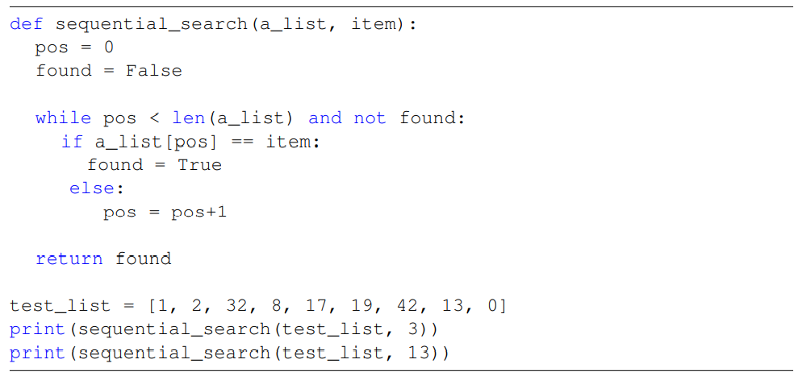

**ORDERED LINEAR SORT**

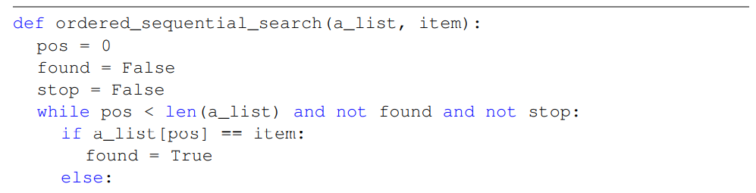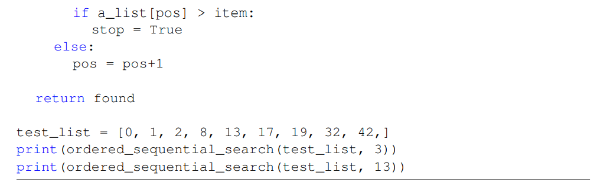

| **CASE** | **BEST CASE** | **WORST CASE** | **AVERAGE CASE** |
| --- | --- | --- | --- |
| Item is present (unordered) | 1 | n | n/2 |
| Item is not present (unordered) | n | n | n |
| Item is present (ordered) | 1 | n | n/2 |
| Item is not present (ordered) | 1 | n | n/2 |

## Binary search (recursive)

**Time complexity: *O(log n)***

Only for ordered lists and it is a divide and conquer strategy

Start from middle element

* If it is the correct item: you win
* if it is lower: eliminate all the one before
* if it is bigger: eliminate all the one after

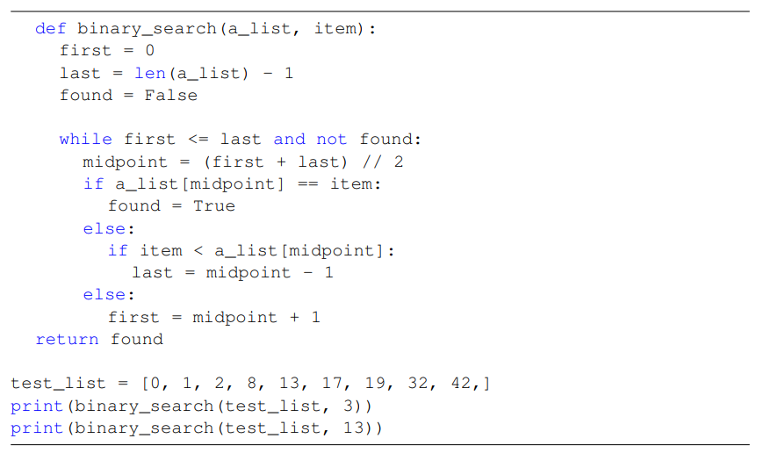

## Hash table search

**Time complexity: *O(1)*** best one :)

Collection of items that are stored in a way that it is easy to find them later

**Slot**: position of the hash table. Each can hold an item and it is named by an integer value (starting at 0)

**Hash function**: mapping between an item and the slot where it belongs. Usually use the remainder method (item / number of slots)

When we want to search an item we use the hash function to compute the slot name for the item and then check the hash table to see if it is present

The time complexity is O(1) since a constant amount of time is required to compute the hash value and then index the hash table at that location

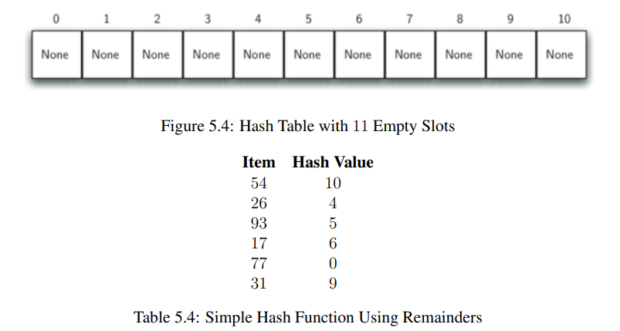

**Sorting**: placing elements in a collection is some kind of order. Sorting a large number of items can take a substantial amount of computing resources. Like searching the efficency is related to the number of items being processed

## Bubble sort

**Time complexity: *O(n2)***

Compare adjacent items and exchange those that are out of order. At the start of the second pass the biggest item is in the correct position: the total number of passes is *n-1*

Mosr inefficent sorting method :(

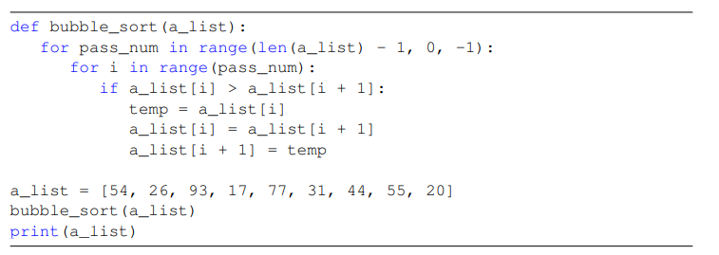

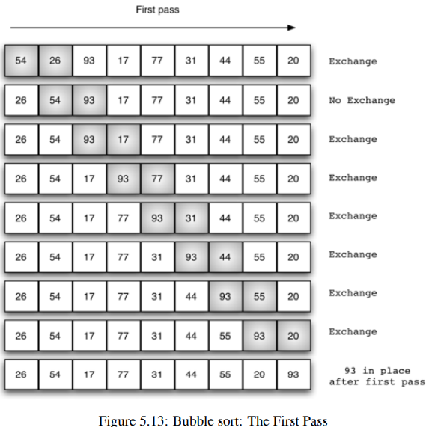

## Selection sort

**Time complexity: *O(n2)***

Improved version of bubble sort. Only one exchange for every pass through the list. Look for the largest value as it makes the pass, after completing the pass places it in the proper location. As bubble sort after one pass the biggest item is placed = requires *n-1* pass

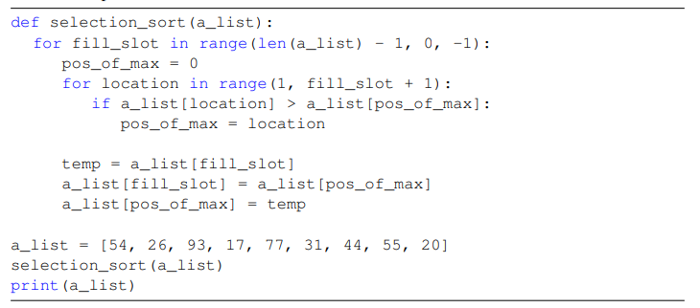

As bubble sort it is also *O(n2)* but it has less number of exchanges and it executes faster in benchmark studies.

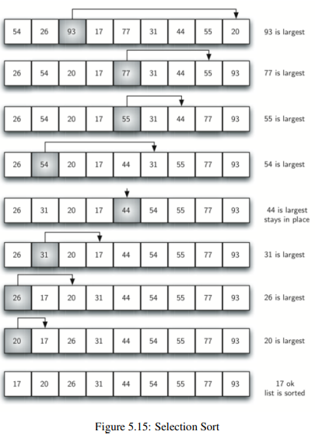

## Insertion sort

**Time complexity: *O(n2)***

[Insertion sort in 2 minutes](https://youtu.be/JU767SDMDvA)

Work in a different way. Maintain a sorted sublist in the lower position of the list, each item is then “inserted” back into the previous sublist is one item larger

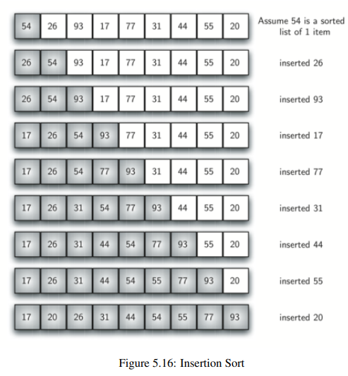

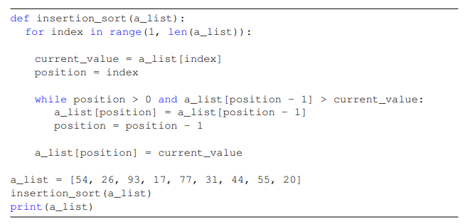

## Merge sort (recursive)

**Time complexity: *O(n log n)***

[Merge sort in 3 minutes](https://youtu.be/4VqmGXwpLqc)

Recursive algorithm

Divide and conquer strategy to improve the performance of the sorting algorithm.

Recursive algorithm that split the list in half. Once the two half are sorted the list is merged

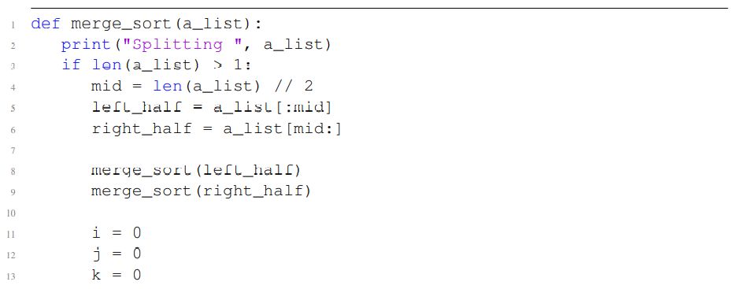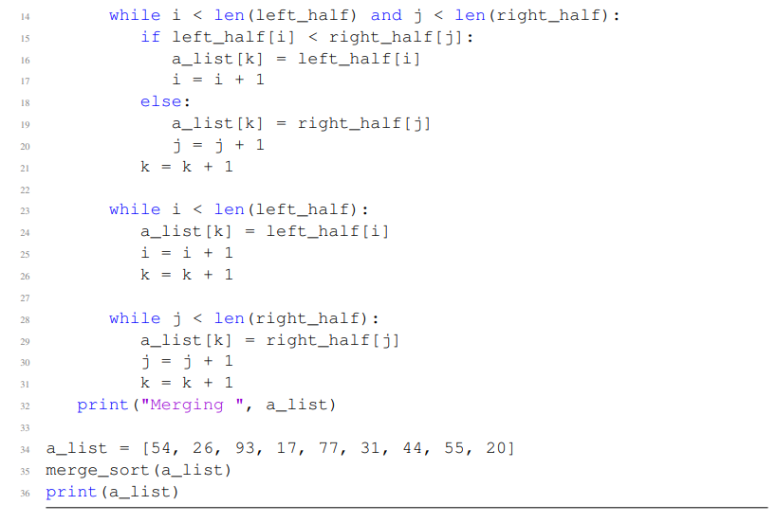

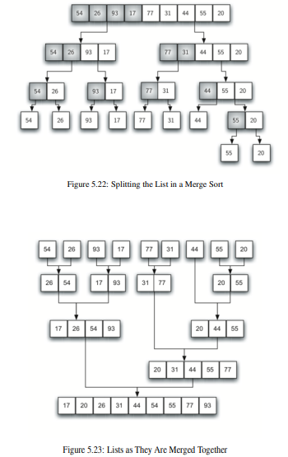

## Quick sort (recursive)

**Time complexity: *O(n log n)***

[Quick sort in 4 minutes](https://youtu.be/Hoixgm4-P4M)

Recursive algorithm

Use **divide and conquer strategy**. First select a pivot value (the first item) that assists in the splitting list and it will go to the split point. Then the partition happens that will fine the split point and at the same time move other items to the appropriate side of the list (less or greater than the pivot value)

PARTITION:

two markers (left and right). We want to move items that are on the wrong side with respect to the pivot value while also covering on the split point.

Increment the left marker until we find a value that is greater than the pivot value and we stop.

Decrement the right marker until we find a value that is less than the pivot value. Then we swap twose two items.

When the rightmark is less than the left mark we stop.

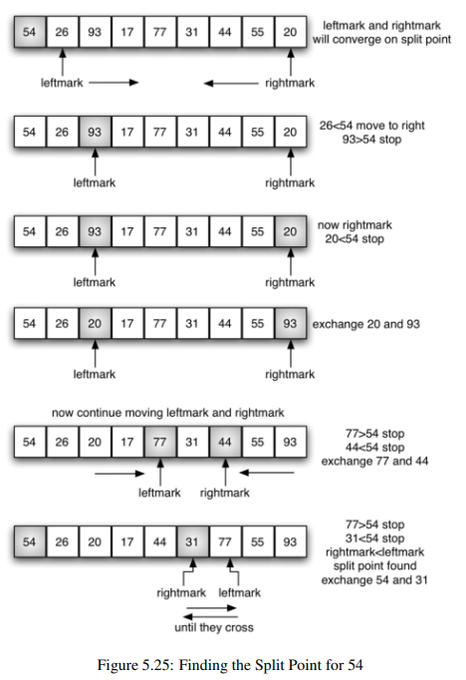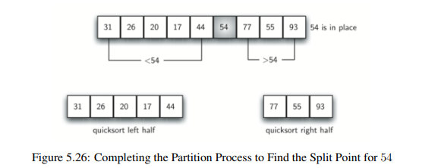

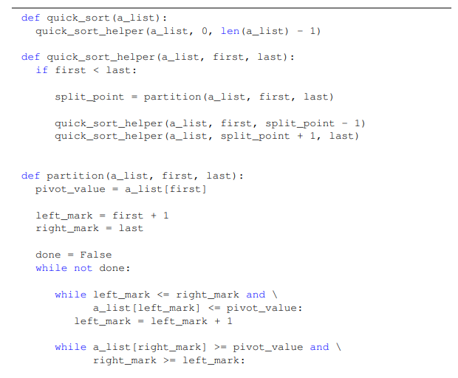

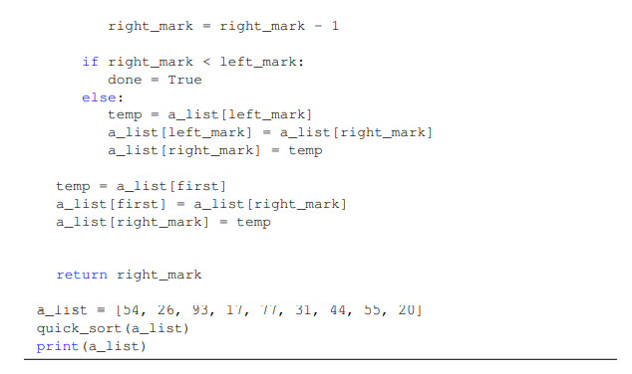

## --- Recap search

|  | **Recursive?** | **What** | **Time complexity** |
| --- | --- | --- | --- |
| **Linear search** | No | Simply look one by one all the items until we find what we are looking for | O(n) |
| **Binary search** | Yes | Ordered list only. Select the middle element. If it is what you are looking for, you finish. Otherwise remove the half-list that is bigger/smaller. Repeat | O(log n) |
| **Hash table search** | No | Items stored in slots. Use hash function to map between item and the slot (remainder method) | O(1) :) |

## --- Recap sort

|  | **Recursive?** | **What** | **Time complexity** |
| --- | --- | --- | --- |
| **Bubble sort** | No | Compare 2-by-2 adjacent items and swap them if they are out of order | O(n2) |
| **Selection sort** | No | Improved version of bubble sort. Find the largest value and place it in the last position | O(n2) |
| **Insertion sort** | No | Maintain sorted list and one by one insert the new element in the correct position | O(n2) |
| **Merge sort** | Yes | Split the list in pieces until there are only single elements that are sorted in with the others recreating the list | O(n log n) |
| **Quick sort** | Yes | Select pivot value (first item) and left and right mark. Swap items when the left is bigger than the pivot and the right is smaller than the pivot. When the markers surpass each other exchange rightmark (that is before leftmark) with the pivot | O (n log n) |

# Trees

## Definition

Trees have roots, branches and leaves but are upside down. Are hierarchical

**Node**: fundamental part of a tree. Can have his name (aka *key*) and addition information (aka *payload*)

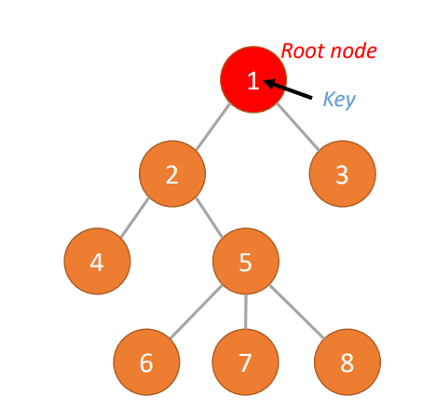

**Edge**: fundamental part of a tree. Connects two nodes to show a relationship between them. Every node (except root node) is connected by one incoming edge from another node

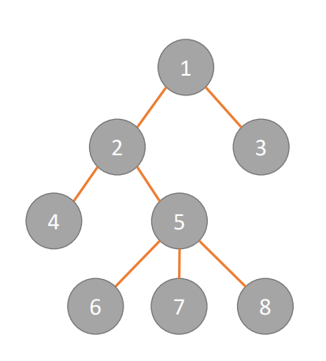

**Root**: Only node of a tree that has no incoming edges



**Path**: ordered list of nodes that are connected by edges (*Mammal → Carnivora → Felidae → Felis → Domestica*)

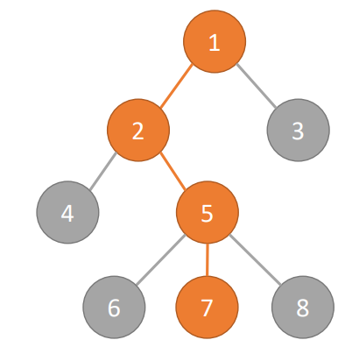

**Children**: set of nodes that have incoming edges from the same node

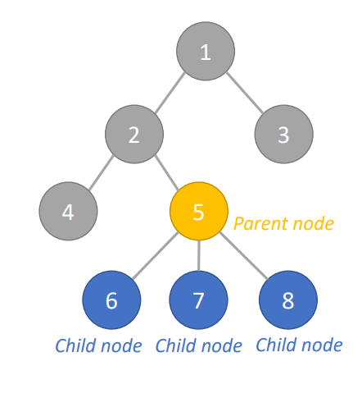

**Parent**: parent of all the nodes it connects to with outgoing edges



**Sibling**: nodes in the tree that are children of the same parent

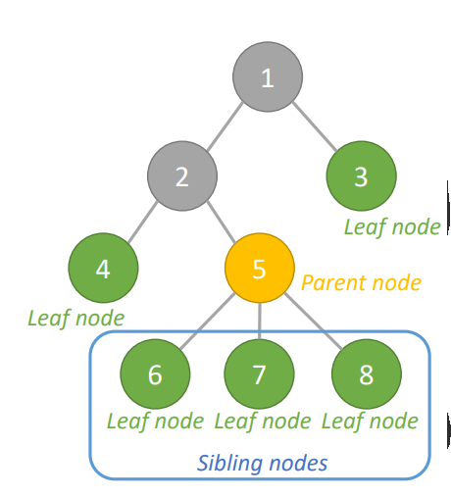

**Subtree**: set of nodes and edges comprised of a parent and all the descendants of that parent (each node is the root of a subtree)

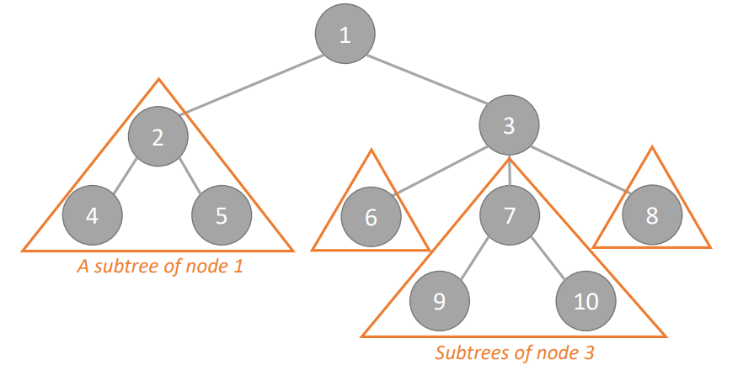

**Leaf node**: node with no children



**Level**: level of a node *n* is the number of edges on the path from the root node to *n*. (the level of the root node is 0)

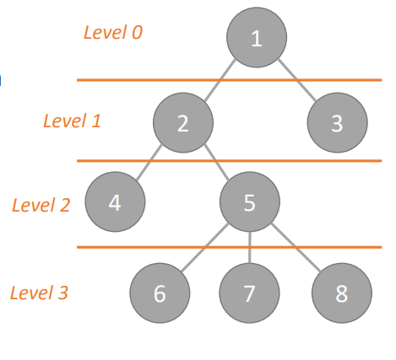

**Height**: maximum level of any node in the tree (the root node is 0!, in the image the height is 3)



**Binary tree**: a tree where a node can have at most two children (called left and right child)

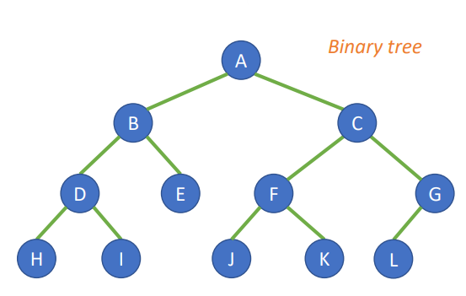

**Height balanced** (for binary tree): if the height of the left and right subtree of any node differ by not more than 1

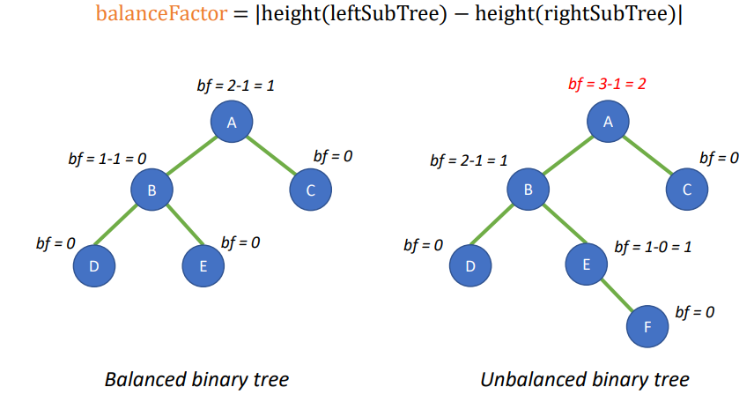

**Perfectly height balanced** (for binary tree): if the left and right subtree of any node have the same height

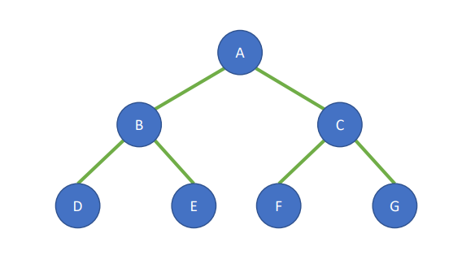

**Complete tree** (for binary tree): if all its levels are completely filled except the last one, which is filled from left to right

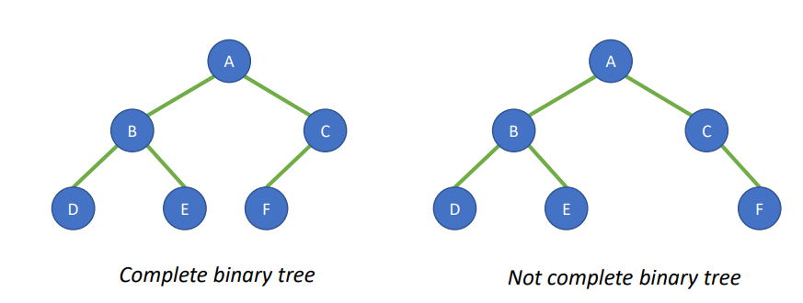

## Tree Traversal

The “visit” of all the nodes in a tree

### Preorder

1. Visit the root node first
2. Recursively do a preorder traversal of the left subtree
3. Recursively do a preorder traversal of the right subtree

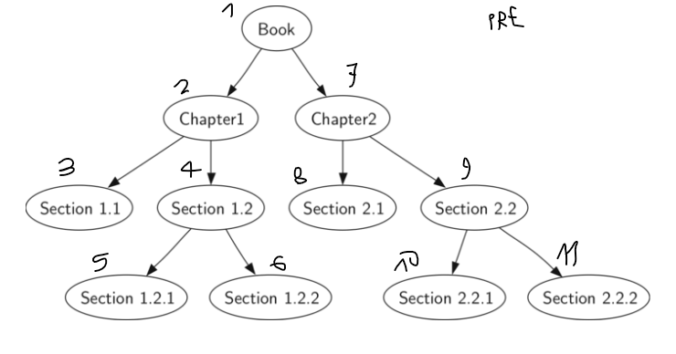

### Inorder

1. Recursively do an inorder traversal on the left subtree
2. Visit the root node
3. Recursively do an inorder traversal of the right subtree

We take the nodes not at the first visit (as with preorder), but at the second visit (so backtracking). When we run into a node with no children we take it and we backtrack

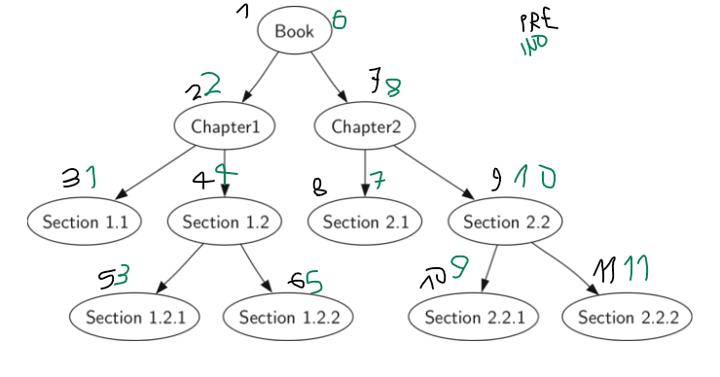

### Postorder

1. Recursively do a postorder traversal of the left subtree
2. Recursively do a postorder traversal of the right subtree
3. Visit the root node

We take the node at the third visit (so when we finish exploring all the subtrees of a node). When we run into a leaf node we take it because it has no subtree

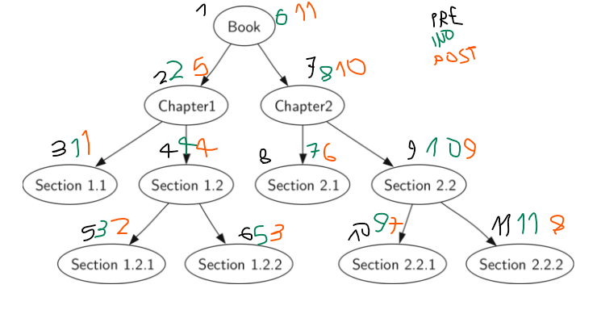

### Level order (breadth-first)

Nodes are visited level-by-level

## Parse tree

Ordered tree that represents the syntactic structure of a string. Can be used to represent real-world construction like sentences or mathematical expressions

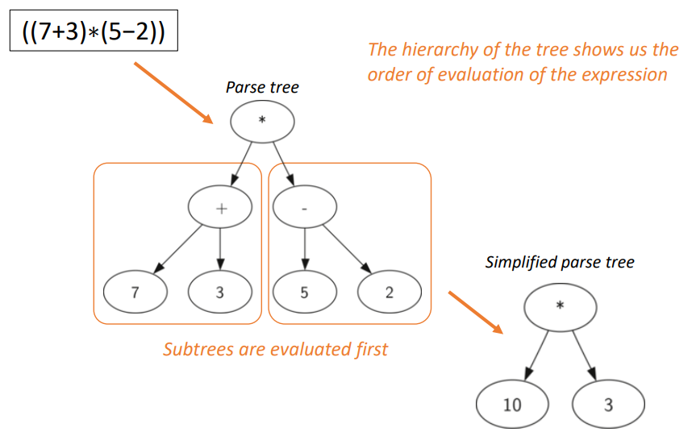

Need a code to

1. Create a tree from a fully parenthesized mathematical expression
2. Evaluate the expression stored in the tree
3. Recover the original mathematical expression from the tree

Rule 1: open parenthesis ⟹ add a left child node and descent to it

Rule 2: write the operator in the current node, add a right child and descent to it

Rule 3: write the number in the current node and return to parent node

Rule 4: close parenthesis ⟹ return to parent node

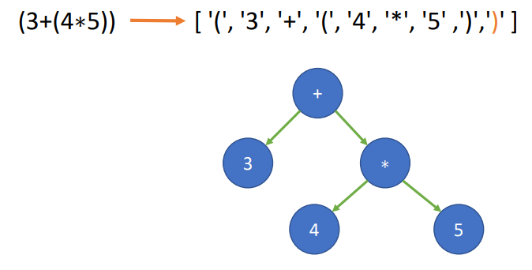

## Binary heap

Is a binary tree with the following properties:

1. It is **complete**: it is a tree which each level has all its nodes, except (eventually) the last one, which is filled from the left to the right
2. It can be a **min heap** or **max heap**: each node has a key smaller/bigger than its children’s key (root node has the minimum/maximum key)

Used for implementing priority queue[1] (most common use) or sorting (aka heap sort)

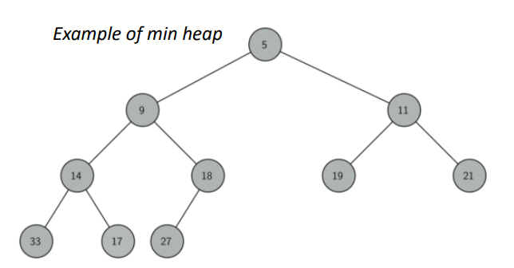

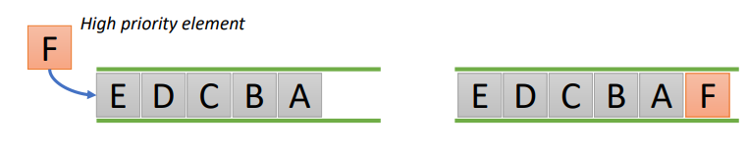

A binary heap can be implemented using a list (easy to find the position of parent/child). First element never used (allows to use integer division, generally simply set to 0)

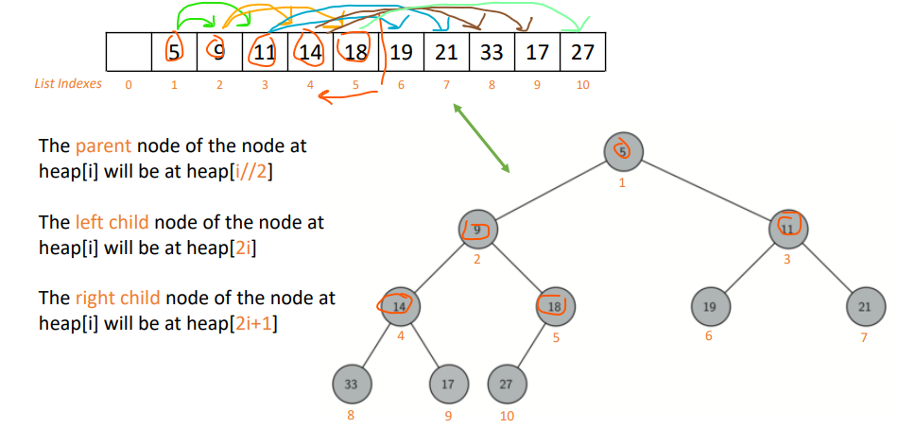

**Min (or max) heapify**: process of reshaping a binary tree in a min (or max) heap

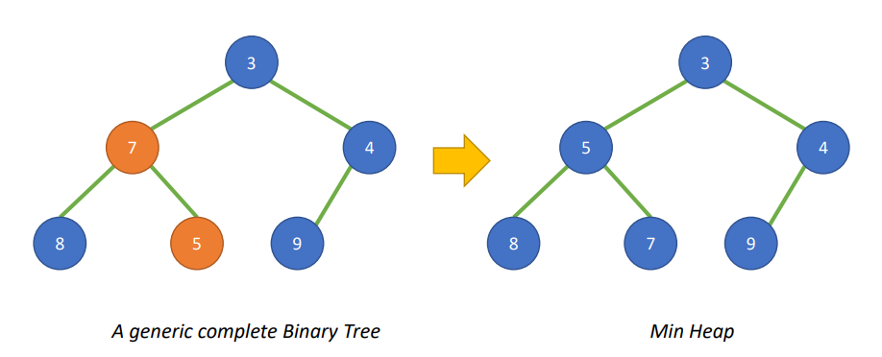

### Insert an element (min heap)

1. Add the new element at the end of the list

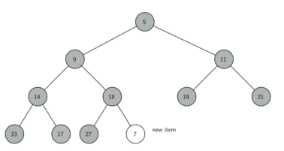

1. If the new element is less than its parent swap their position

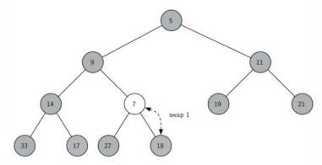

1. Repeat the swap until the new element is in the right position

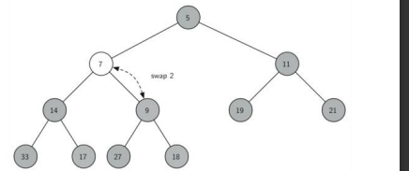

### Extract the min element (min heap)

1. Remove the root node (smallest element)
2. Move the last node to root (this operation does not alter the remaining of the heap structure)

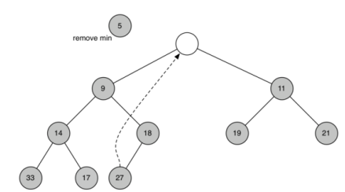

1. Restore the heap order by pushing the new root node down the tree to its proper position (heapify down)

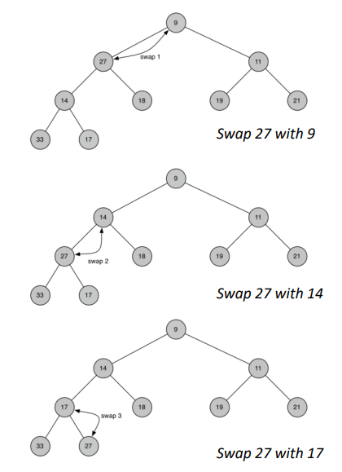

## Binary search tree (BST)

Another way to map from a key to a value

Binary tree in which the nodes are ordered so that:

* Node with keys that are less than the parent key are in the left subtree
* Node with keys that are more than the parent key are in the right subtree

Insert and delete operation ⟹ average *O(log n)*

Can perform additional operations

* Sort the keys (simply doing an inorder traversal)
* Find maximum and minimum elements
* Find predecessor and successor of an element

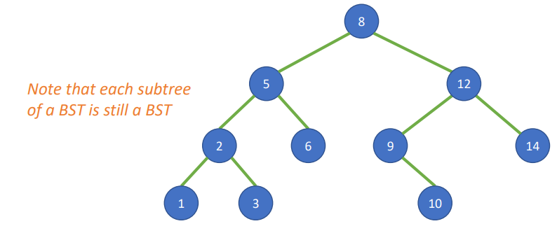

1. Deleting one node with one children ⟹ move the subtree up
2. Deleting a node with two children ⟹ search among the children the node that will preserve the binary search tree relationship for both the existing left and right subtree. The node that will do this is the node that has the **next-largest key** in the tree, and it is called **successor** node

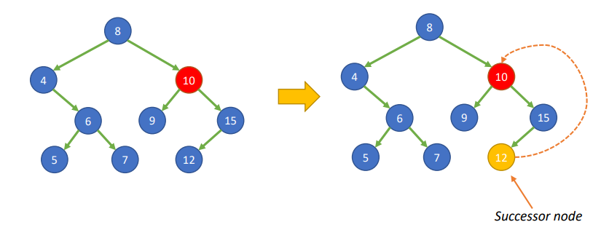

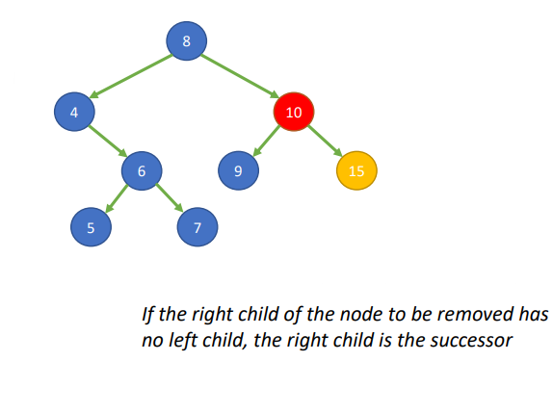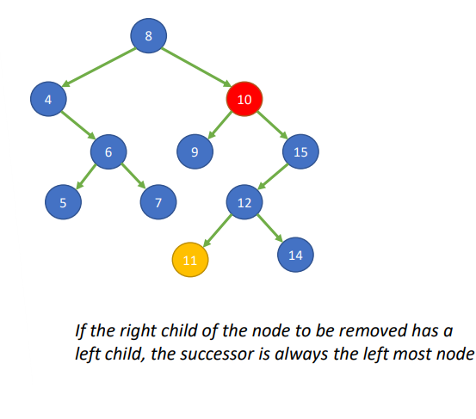

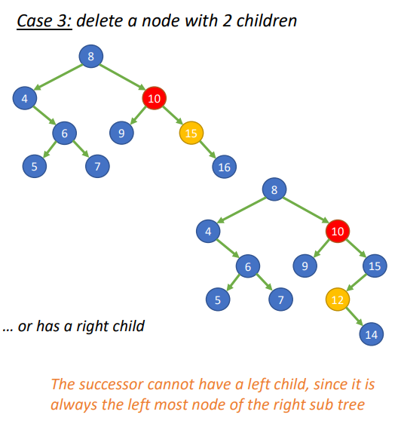

#### Example 1

Example: insert the nodes 8 and 9

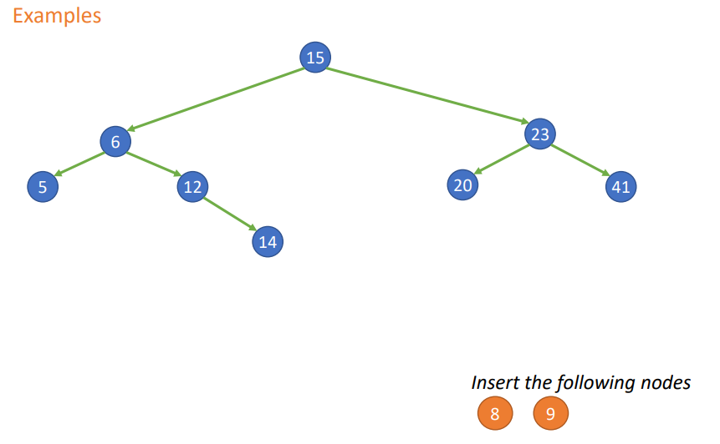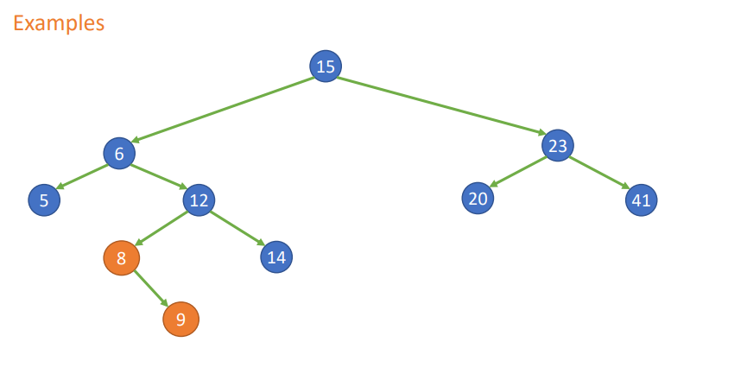

Remove node 6 ⟹ 8 is the successor node of 6 (since 6 have a right child we have to take the leftmost child of the right child of 6)

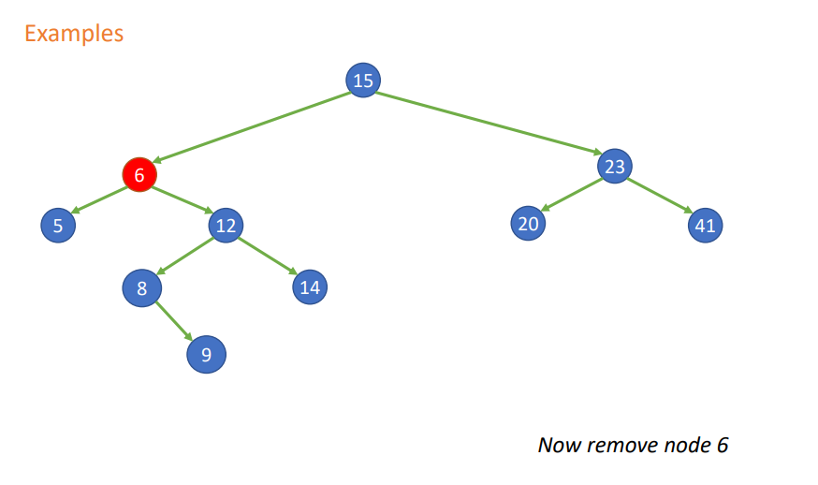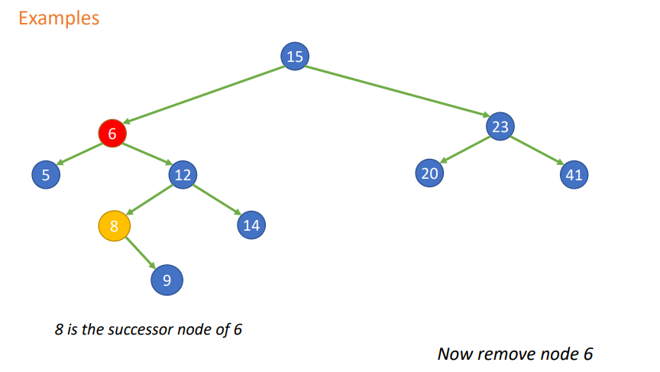

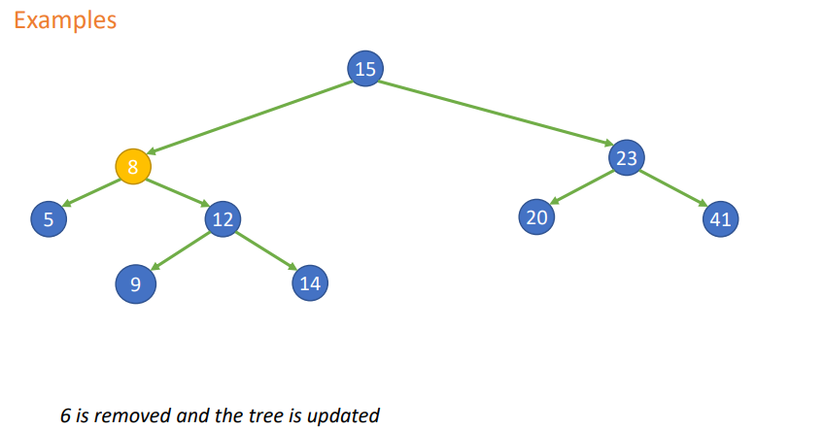

#### Example 2

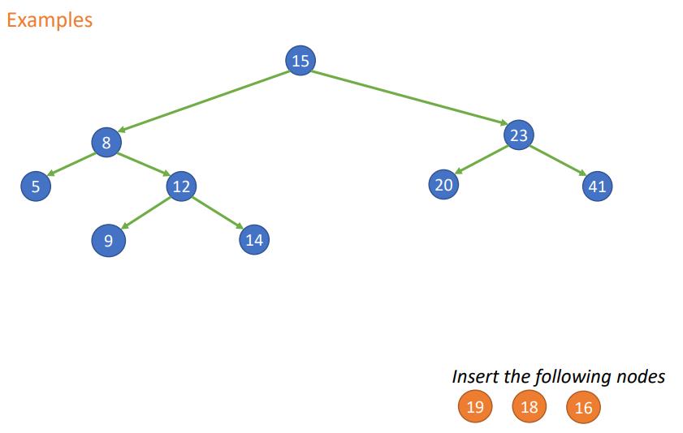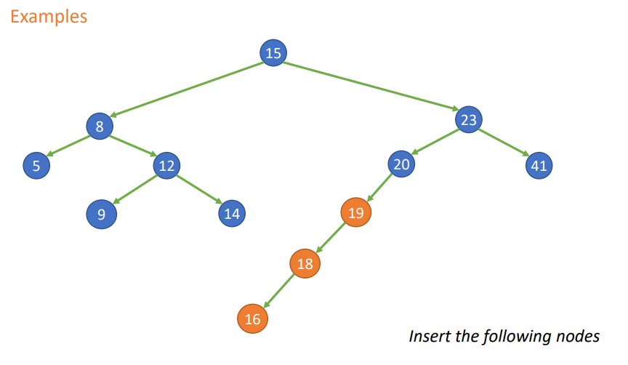

BALANCE:

Performance of BST depends by how the keys are added to the tree

* If the keys are added in random order about half of them will be lees of the root and half more, so is a (quite) **balanced tree** ⟹ O(log n)
* Else, if they are sorted in order the tree will be **unbalanced** ⟹ O(n)

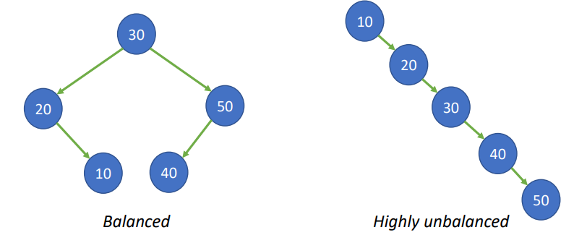

## Self balancing tree (AVL Tree)

Type of search tree that keeps its height small after an insertion or a deletion

AVL Tree makes sure that the tree remains height balanced after an insertion or deletion. The difference between the right and left subtree can not be more than one for all the nodes.

Each node have a **balance factor (BF)**, if it is > 1 or < -1 it is unbalanced and the tree needs to be rebalanced :

*balance factor = height(leftSubTree) - height(rightSubTree)*

If it is < -1 the tree is rebalanced performing a **left rotation** of the subtree

If it is > 1 the tree is rebalanced performing a **right rotation** of the subtree

Every time there is a change in the tree (adding or removing) the balanced factor of all the parent node is updated, until

* The recursive call has reached the root of the tree
* The BF of the parent has been adjusted to zero
* A node becomes unbalanced

#### Left rotation (BF < -1)

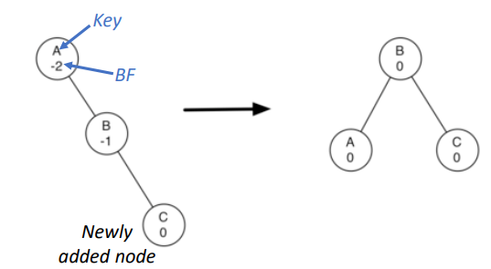

* Promote the right child (B) to the root node of the subtree
* Move the old root (A) to be the left child of the new root
* If the root (B) already had a left child, then make it the right child of the new left child (A)

#### Right rotation (BF > 1)

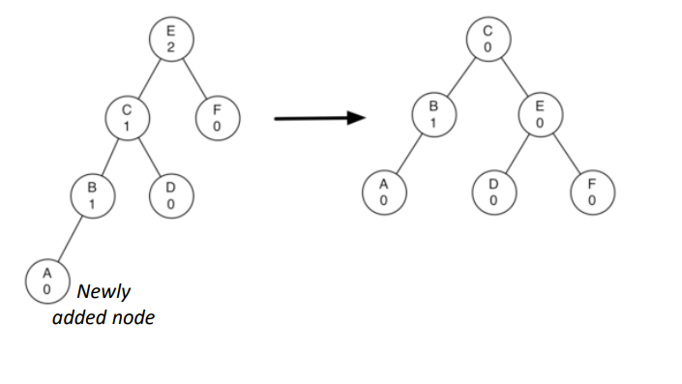

* Promote the left child (C) to be the root of the subtree
* Move the old root (E) to be the right child of the new root
* If the nrw root (C) already had a right child (D) then make it the left child of the new right child (E)

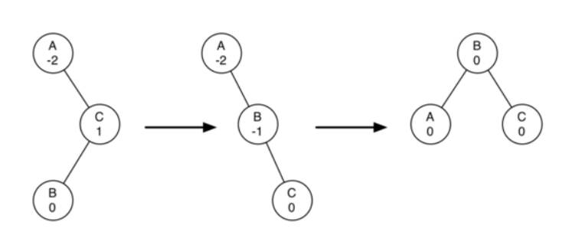

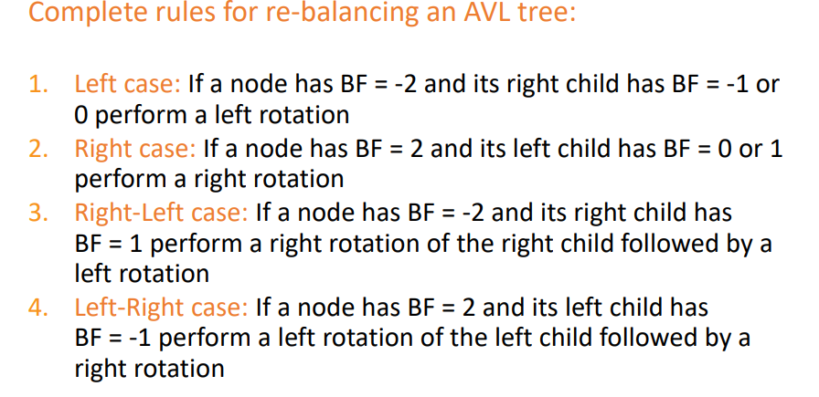

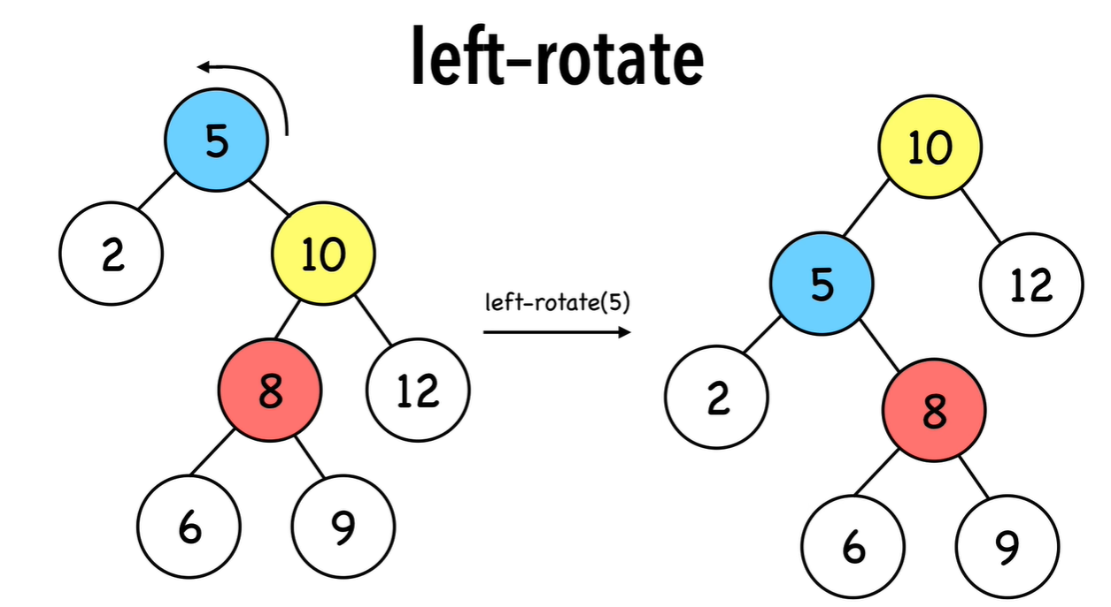

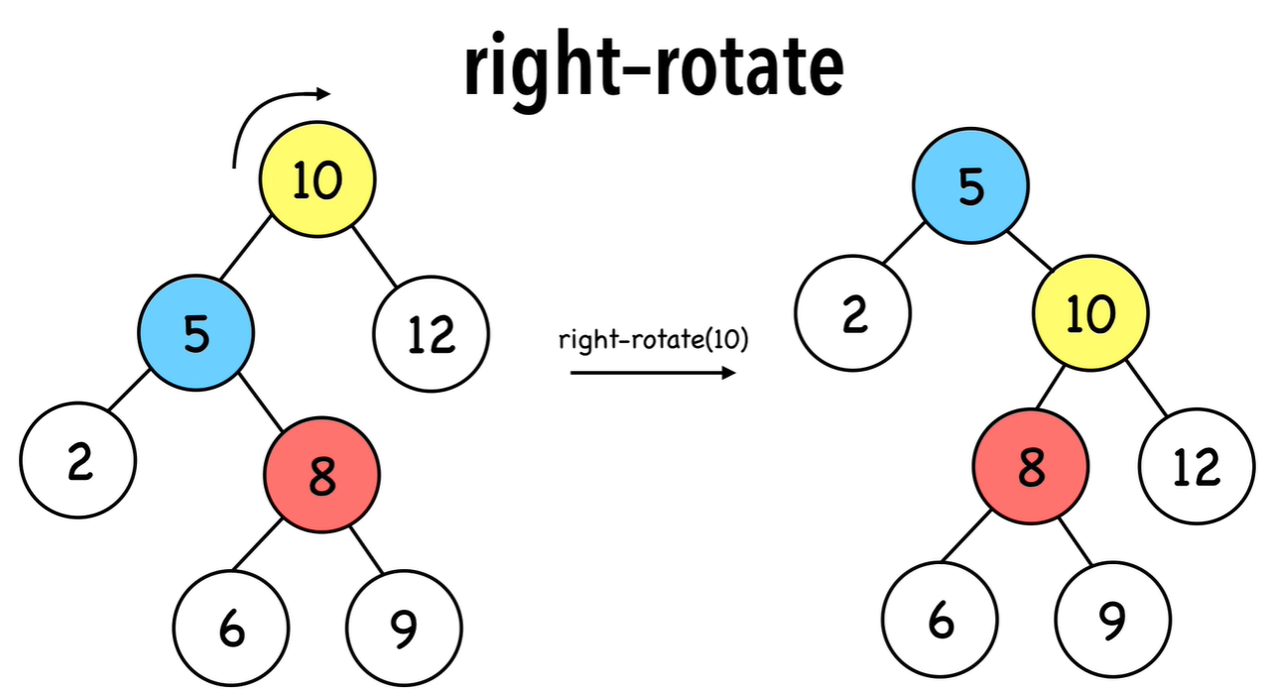

##### Example of insertion 1

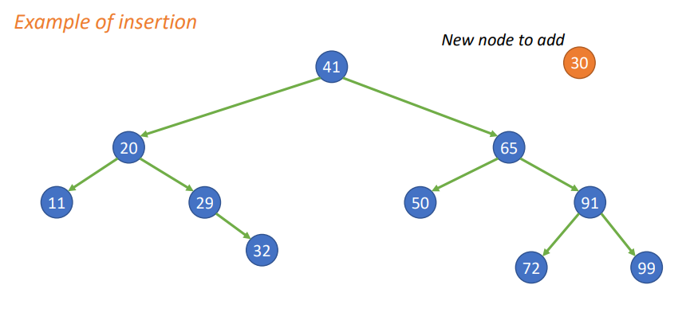

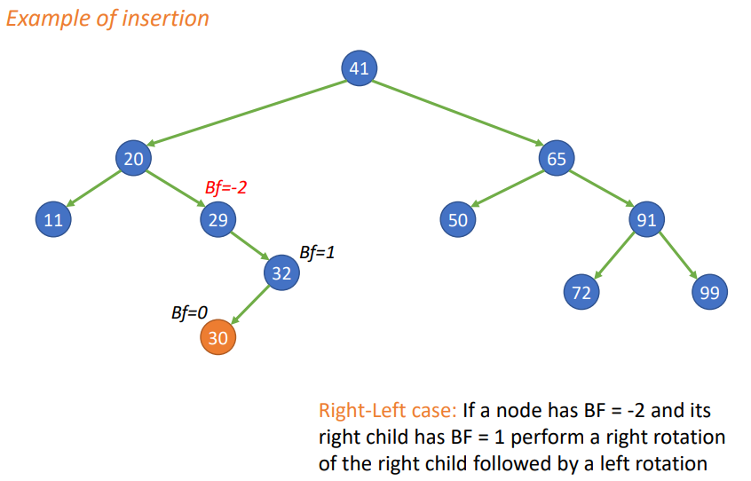

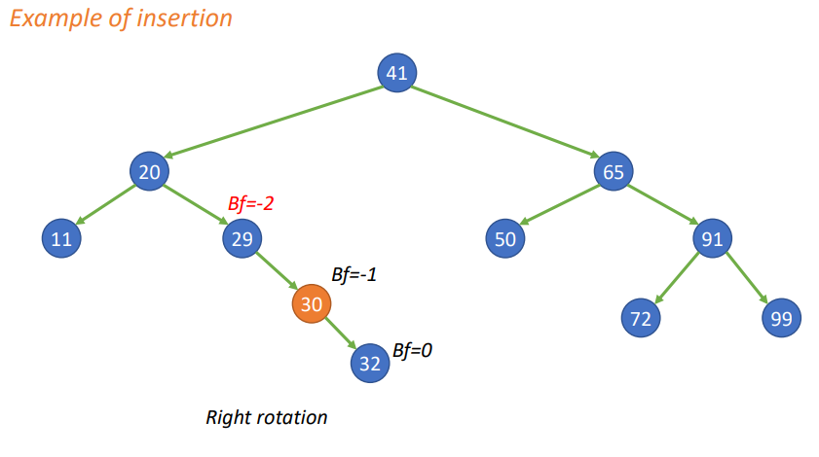

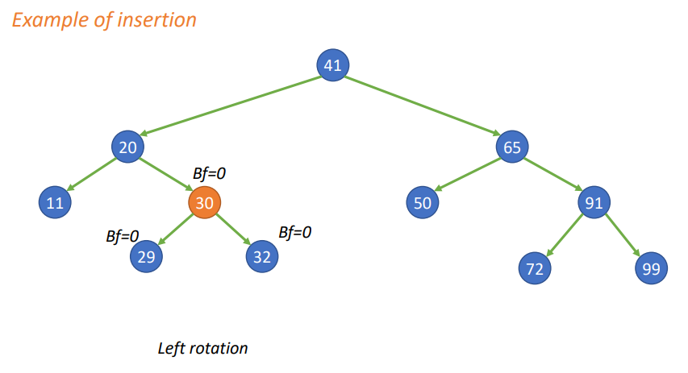

##### Example of insertion 2

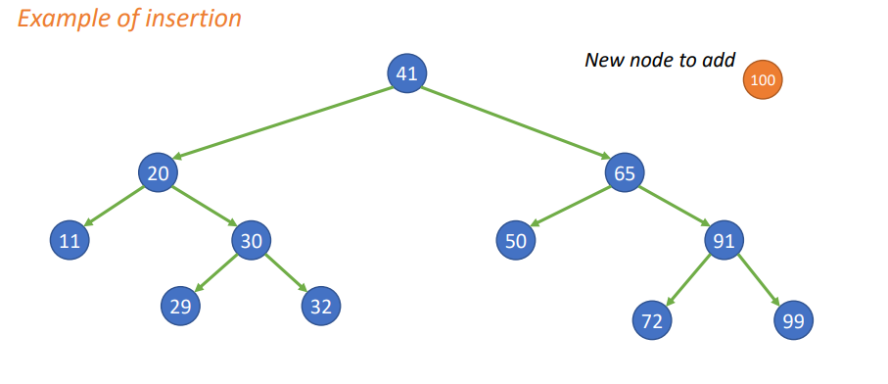

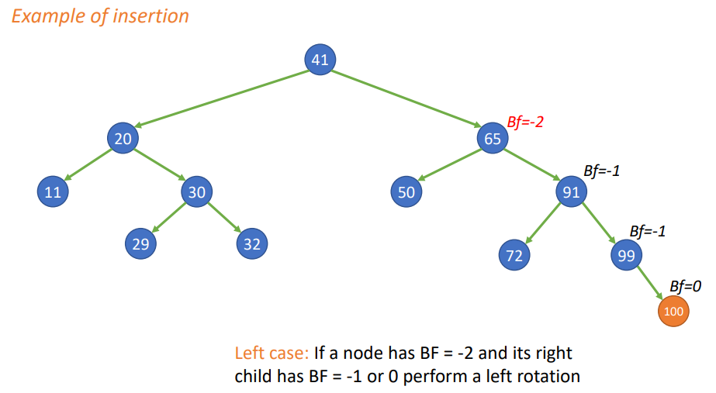

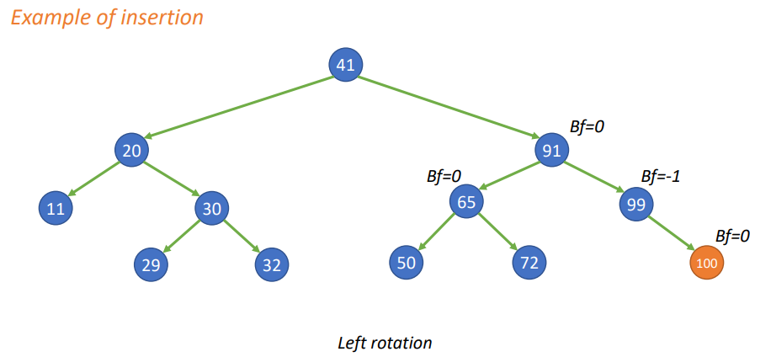

##### Example of deletion

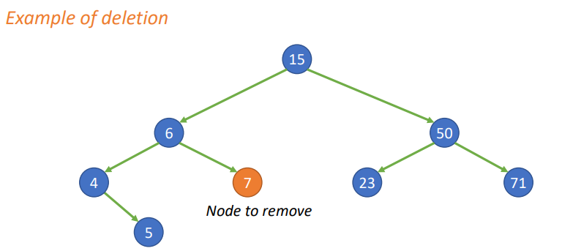

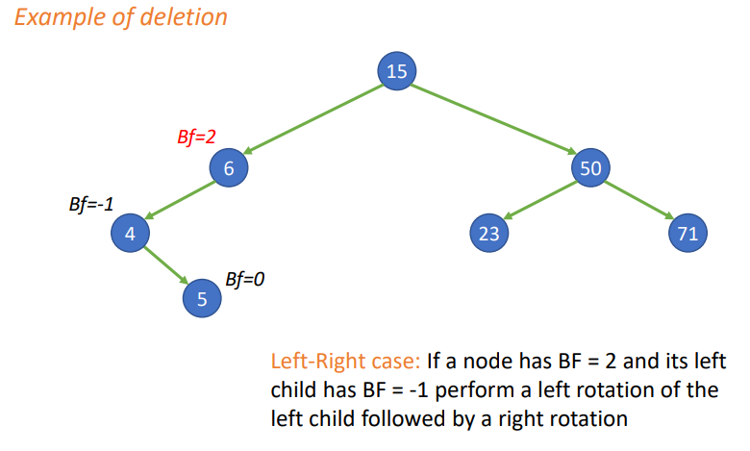

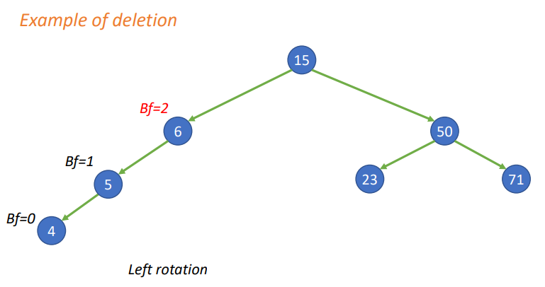

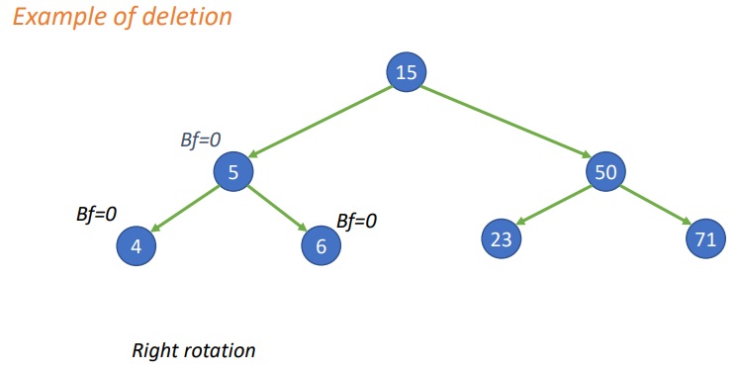

### Red-black tree

[Red-black trees in 4 minutes — The basics](https://youtu.be/qvZGUFHWChY)

[Red-black trees in 3 minutes — Rotations](https://youtu.be/95s3ndZRGbk)

[Red-black trees in 5 minutes — Insertions (strategy)](https://youtu.be/5IBxA-bZZH8)

Self-balancing binary search tree where each node have also a color (red or black) that ensure that the tree remains balanced during insertions and deletions

Computational complexity on average of *O(long n)*

Red-black tree have a virtual leaf node called NIL that do not contain any data or keys

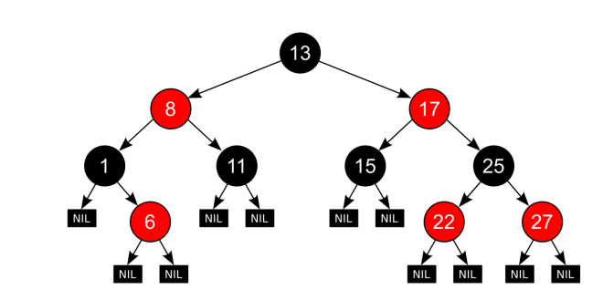

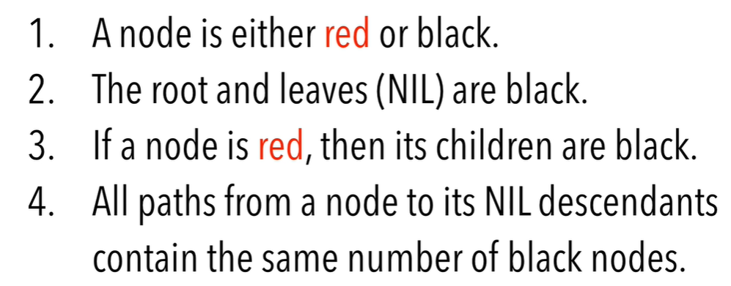

rule 4 (the shortest one is all black, the longest one is red and black alternating)

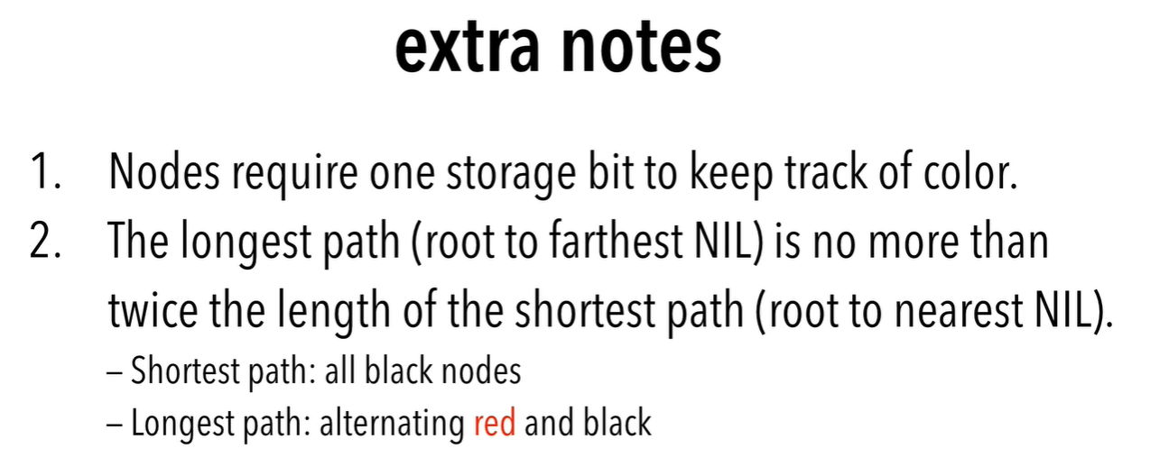

Balancing a tree will disrupt its original structure, altering some (or all) the dependances parent/child.

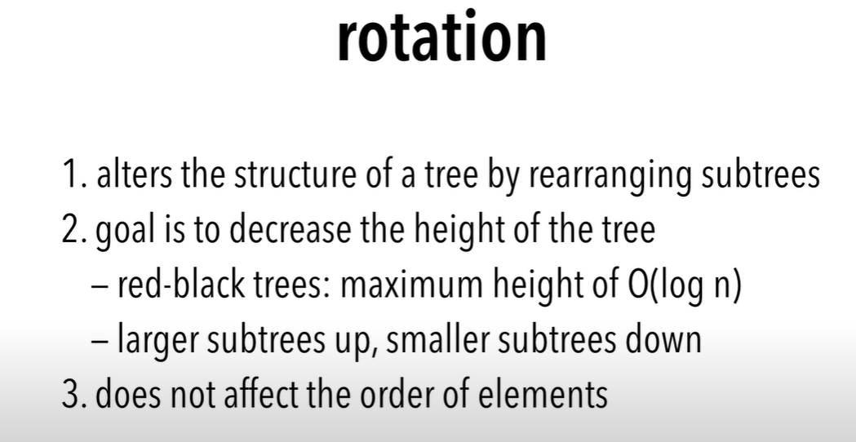

# Graphs

Lecture 8 min 17.40

Non-linear data structure (like tree) composed by nodes and edges that connect them (each node can have any number of edges). But **no hierarchy, no root node, no parent/child and cycles are possible**. Tree can be seen as a special kind of graphs with hierarchy and no cycle

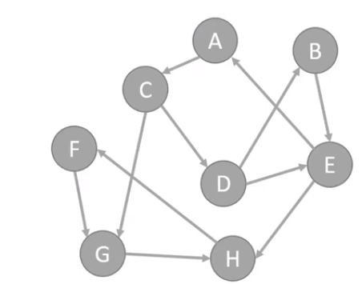

Graphs represent a lot of things (roads maps, airline flights, internet connection…) use to solve a large variety of problems (find shortest path to destination)

## Definition

**Vertex** (aka node): fundamental structure of a graph. It has a name called key, can have additional information (aka payload)

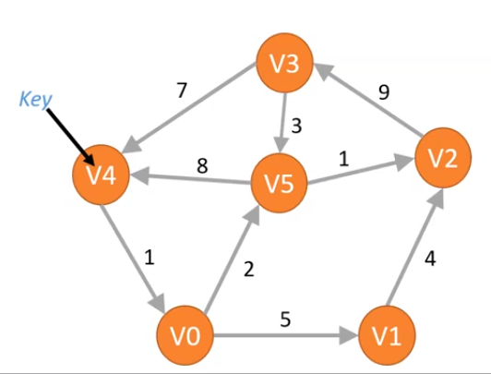

**Edge** (aka arc): connects two vertices to show a relationship between them. Can be one-way or two-way.

* DIRECT GRAPH (aka digraph): all the edges in a graph are one-way
* INDIRECT/UNDIREC GRAPH: all the edges are in two-way (the arrows can be omitted)

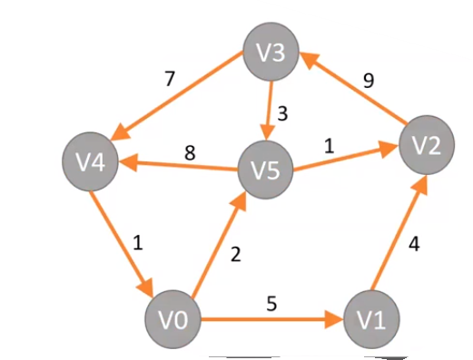

**Weights**: show a cost to go from one vertex to another (ex: distance from one city to another)

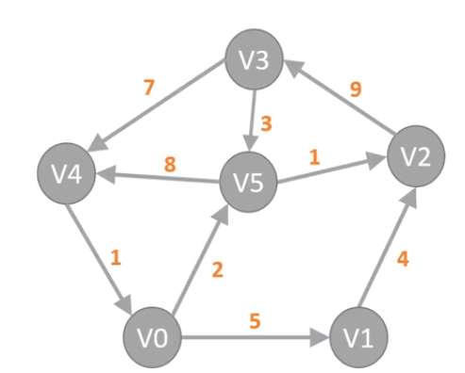

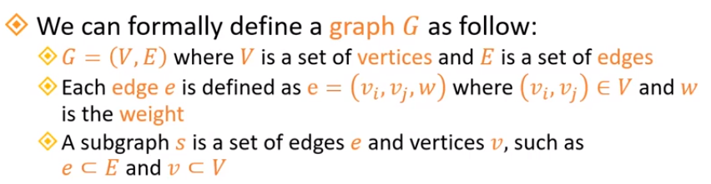

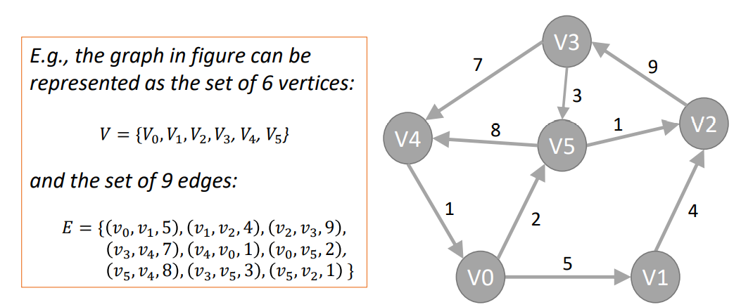

**Path**: sequences of vertices that are connected by edges

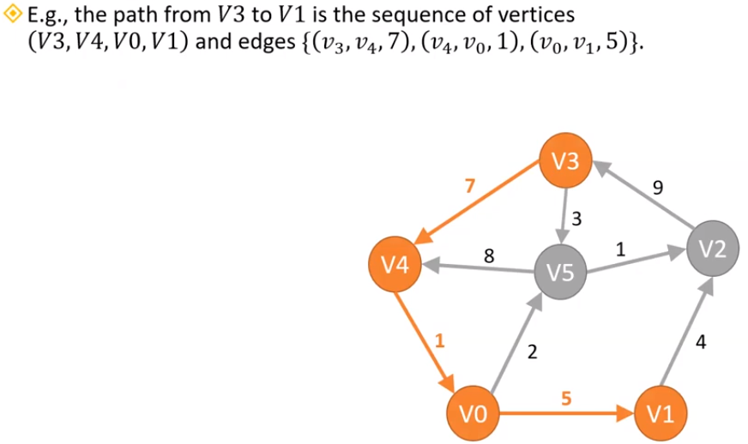

**Cycle**: path that starts and ends at the same vertex. A graph with no cycles is called an acyclic graph. The path (V5, V2, V3, V5) is a cycle

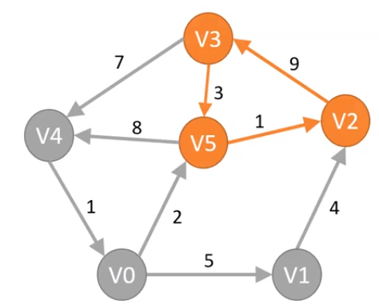

**Adjacent** (aka neighbors): when two vertices are connected by an edge they are adjacent

**Connected graph**: if any two vertices of the graph are connected by a path

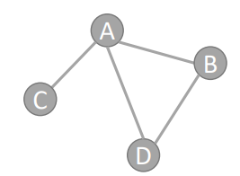

**Disconnected graph**: if at least two vertices of the graph are not connected by a path

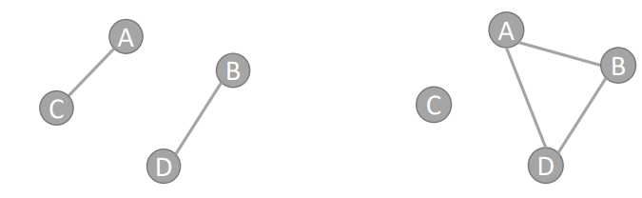

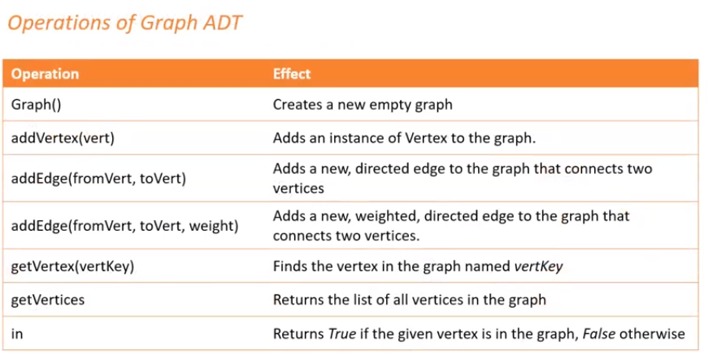

## How to implement a graph

Two ways: **adjacency matrix**, **adjacency list**

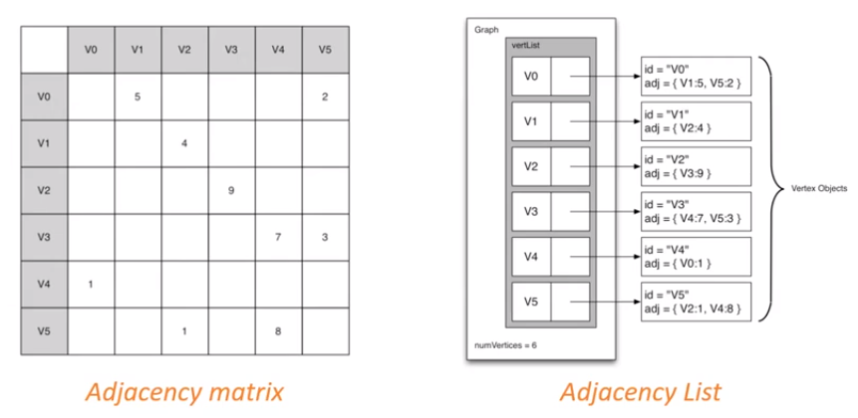

### 

### Adjacency matrix

The row and column are vertex, the value in the cells indicate the weights ( empty ⟹ weight = 0 ⟹ no edge)

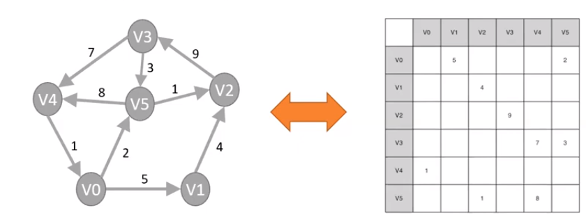

| **PROS** | **CONS** |
| --- | --- |
| Easy to read | High memory usage O(V2) (V = number of vertices) |
| Good representation for dense graph (lot of edges and connections) | Very inefficient for sparse graphs (few edges and connections) |
| O(1) time for adding/removing an edge and to verify if it exists | Adding or removing a vertex requires O(V2) time |

### Adjacency list

Keep a master list of all the vertices in a graph object

Each vertex object in the graph maintains a list of the other vertices that it is connected to (plus the weight if present)

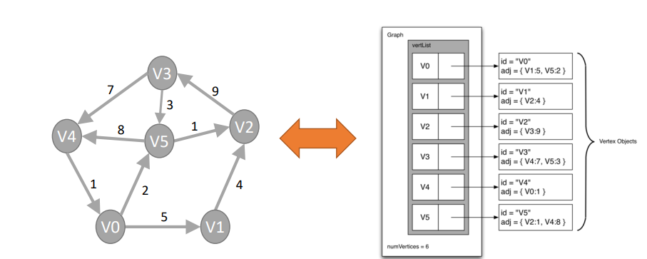

| **PROS** | **CONS** |
| --- | --- |
| Memory efficient, O( |V| + |E| ) space complexity, where V is the number of vertices and E is the number of edges | Not efficient for dense graph |
| Good for representing sparse graphs | Removing an edge or verify if it exist requires O( |V| ) time |
| O(1) time for adding a vertex or an edge |  |

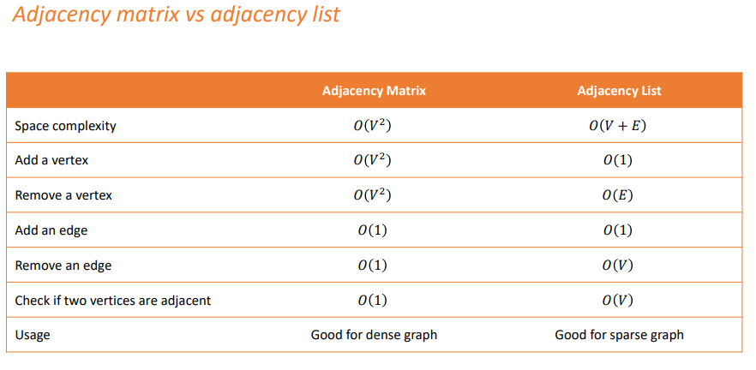

## Breadth first search (BFS)

[Breadth-first search in 4 minutes](https://youtu.be/HZ5YTanv5QE)

Searching algorithm it expands the “frontier” between discover and undiscovered vertices breadthwise

Given a graph G = (V, E) and a source vertex *s*, BFS explores all the edges of G to find every vertex for which there is a path from *s*

### Properties

1. BFS finds all the vertices that are at distance k from s before finds any vertices that are a distance k+1
2. It computes the **shortest path** (smallest number of edges) from s to each reachable vertex
3. It produces a **breadth first tree**, with root s, that contains all the reachable vertices
4. Color each of the vertices in white, gray or black
   1. **white** ⟹ not yet discovered (each vertex initialized as white)
   2. **gray** ⟹ visited for the first time (aka discovered) but not yet completely explores
   3. **black** ⟹ completely explored (it has no adjacent white verites)
5. Construction of the breadth first tree
   1. Source vertex *s* becomes the root node
   2. Whenever BFS finds a white vertex v adjanet to a discovered vertex u, v and the edge (u,v) added to the tree (u predecessor/parent of v)
6. d

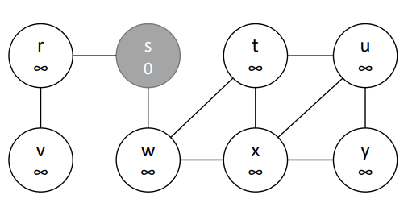

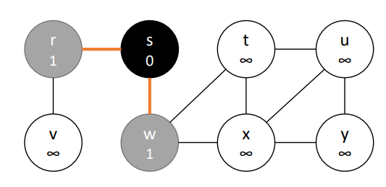

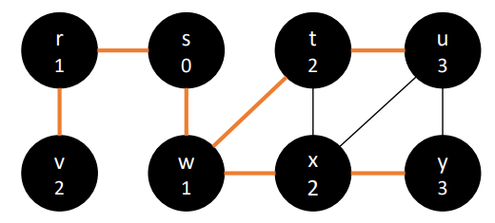

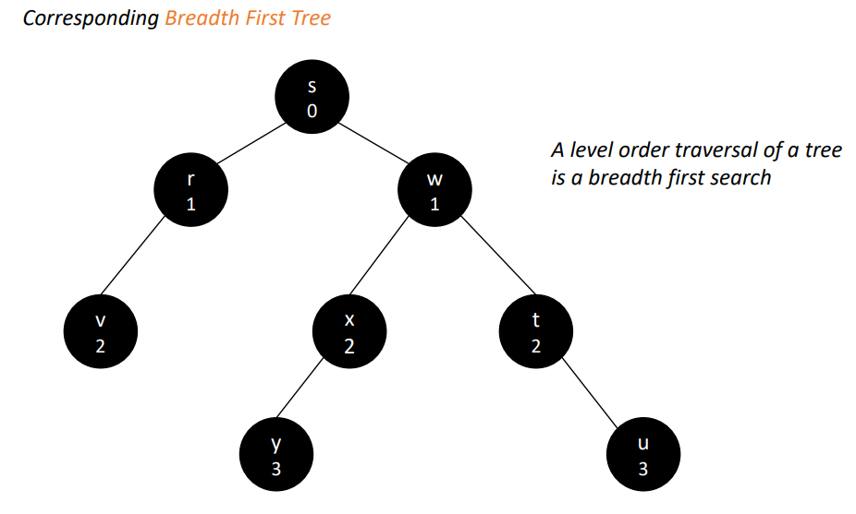

## Depth first search (DFS)

[Depth-first search in 4 minutes](https://youtu.be/Urx87-NMm6c)

Algorithm that explores the graph as deeply as possible along each branch before backtracking

* Where DFS reach a vertex it marks it as visited, then move to an adjacent unmarked vertex and continues recursively until there are no more adjacent unmarked vertexes
* Then DFS backtracks and check different edges for finding other unmarked nodes following the same recursive procedure
* The process continues until all the vertex have been visited
* Color each of the vertices in white, gray or black (same as BFS)
  + **white** ⟹ not yet discovered (each vertex initialized as white)
  + **gray** ⟹ visited for the first time (aka discovered) but not yet completely explores
  + **black** ⟹ completely explored (it has no adjacent white verites)
* Track two timestamps for each vertex
  + **Discovery time**: records numbers of steps in the algorithm before a vertex is first encounter (aka go gray)
  + **Finish time**: records number of steps to have a fully explored vertex (aka black)

BFS ⟹ create a single tree

DFS ⟹ create a group of search trees (aka depth first forest)

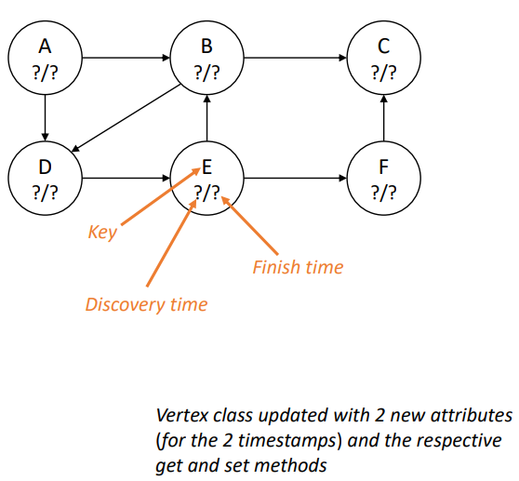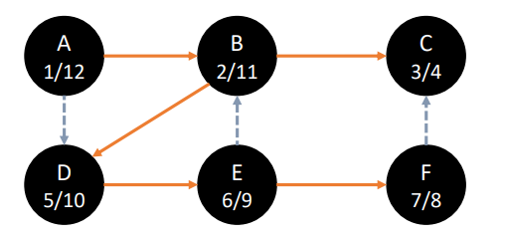

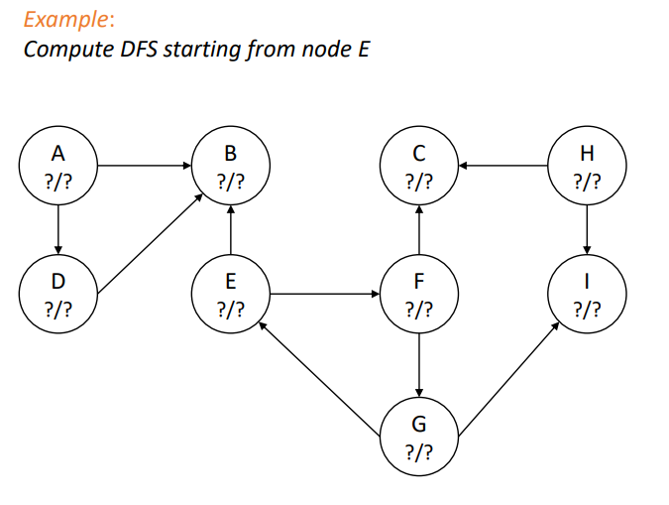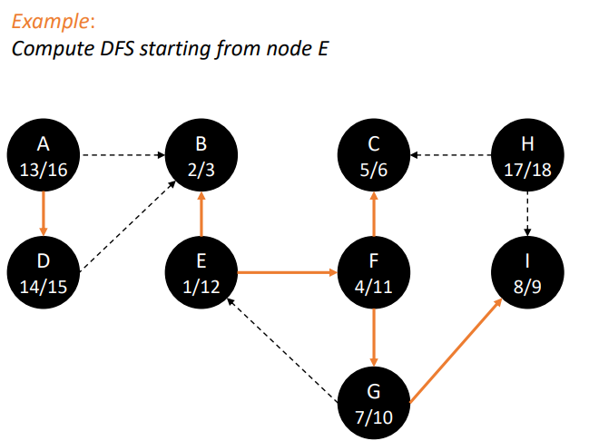

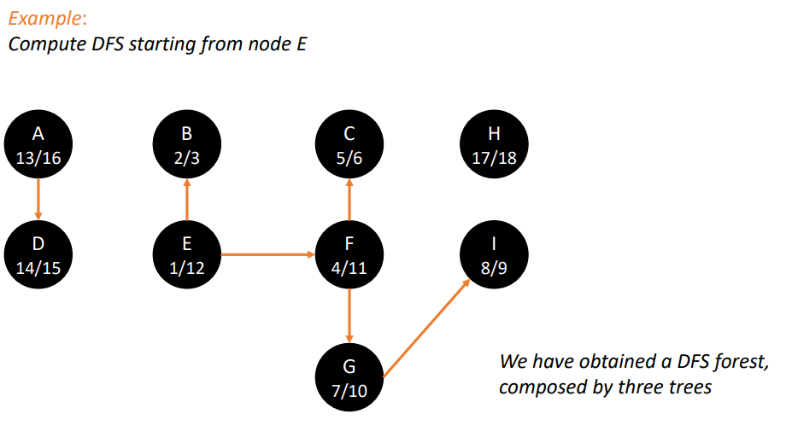

(part 2)

## Topological sorting

Acyclic graph ⟹ (DAG) produces linear ordering of all its vertices such that if there is an edge (v,w) then the vertex v come before the vertex w

If the graph is not acyclic then it can not be done

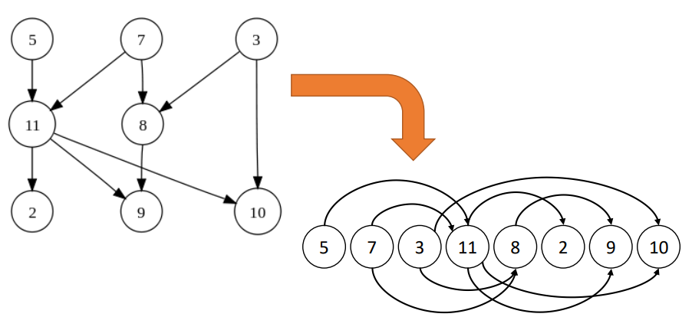

There can be multiple topological sorts possible, but the first vertex must be always a vertex with no incoming edges

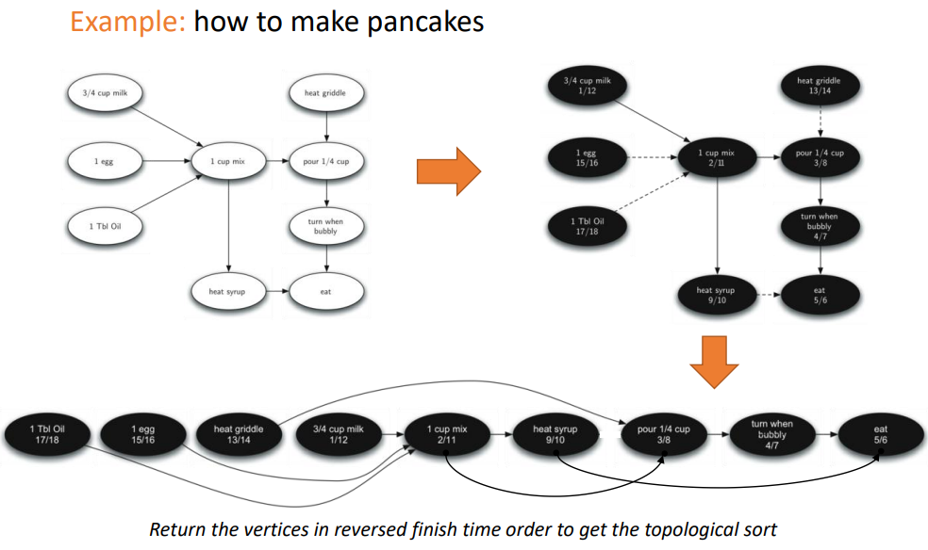

## Strongly Connected Components (SCC)

**Strongly connected** (for direct graphs): if every vertex is reachable by any other vertex (aka if exist a path from each vertex to each other vertex)

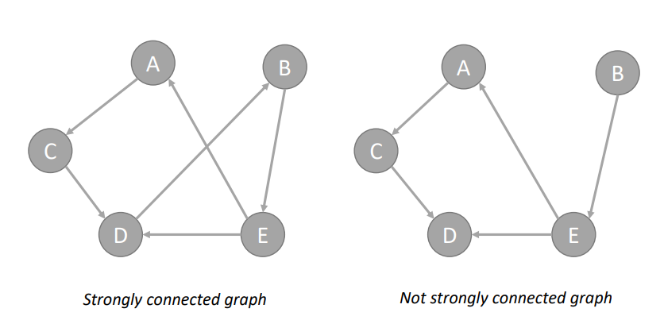

**Strongly connected component (SCC)**: subgraph of G that is strongly connected

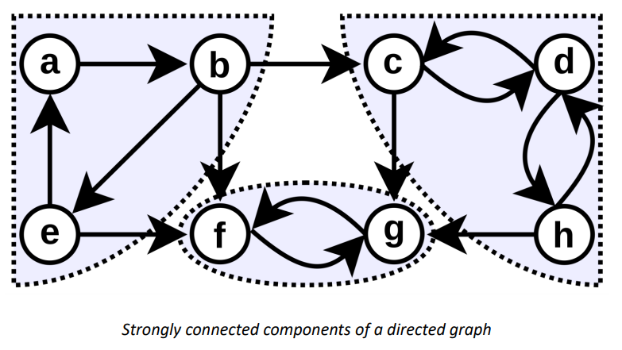

#### Compute SCC

1. Run DFS on the graph G to compute the finishing times of each vertex

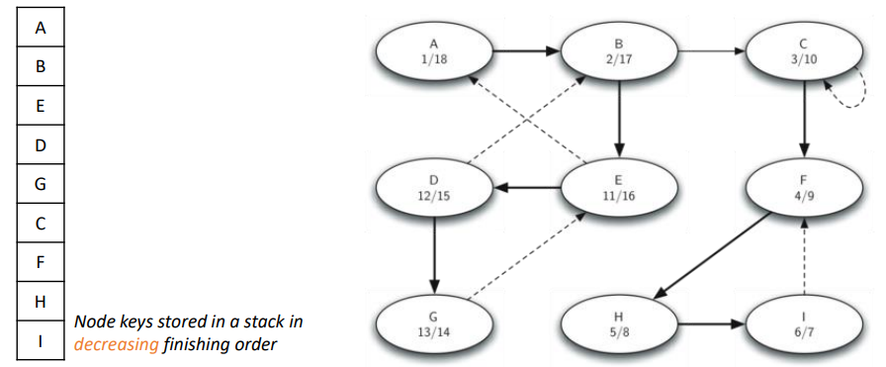

1. Compute the graph GT, the transposition of G (reverse direction of all the edges)
2. Run DFS on GT but consider the vertexes in order of decreasing finishing time as compute in step 1

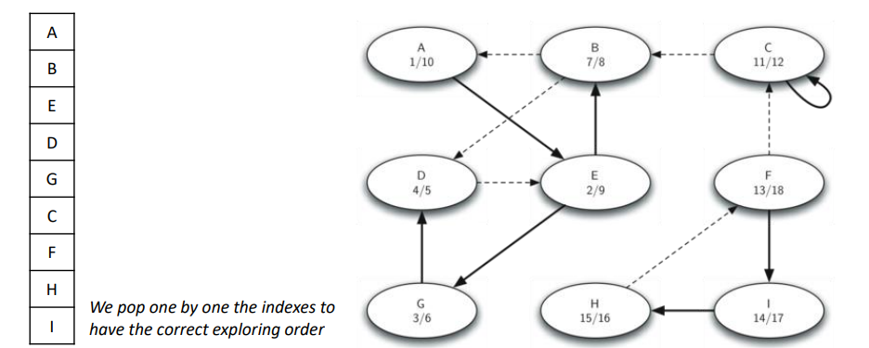

1. Each tree in the forest computed in step 3 is a strongly connected component

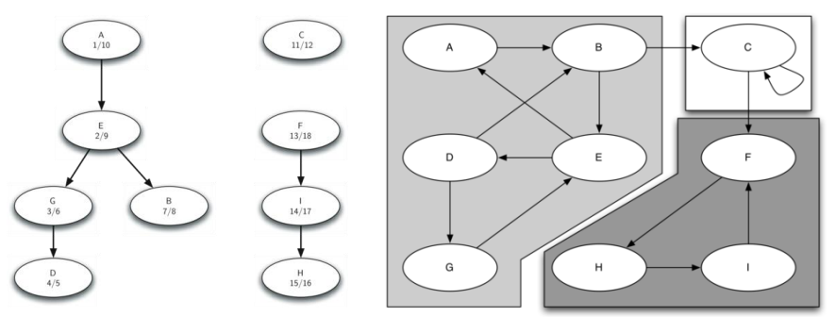

## Minimum spanning tree

**Spanning tree**: acyclic subgraph that connects all the vertices of the graph (a graph can have multiple spanning trees)

**Minimum spanning tree** (for connected undirected weighted graph): spanning tree in which the sum of the edge weights is minimized. (In unweighted graphs any spanning tree is also a minimum spanning tree)

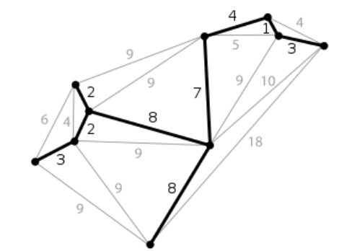

Minimum spanning tree can solve common network problems such as the **broadcast problem** (transfer an information from one host to any possible listener connected to the network)

### Broadcast problem

The host has some information that all the listeners need to receive

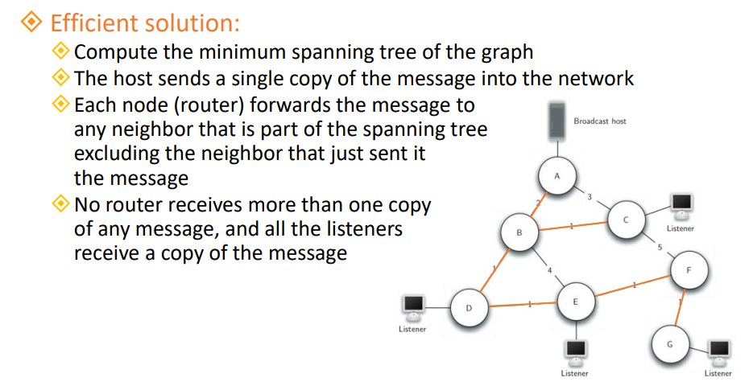

## Prim’s spanning tree algorithm

[Prim's algorithm in 2 minutes](https://youtu.be/cplfcGZmX7I)

Algorithm to compute the minimum spanning tree of a graph. **Greedy algorithm** since at each step it adds to the tree the safe edge with the lowest weight. Choose the one with the smallest weight

—-----------------

Greedy algorithms: solve a problem by choosing at each step the local optimal solution

Dijkstra and Prim are greedy algorithm

A greedy algorithm can be used to solve a problem if it has the following properties:

* **Greedy choice property**: global optimal solution can be reached by choosing the optimal choice at each step
* **Optimal substructure**: optimal solution of the problem can be obtained from optimal solutions of its sub-problems

In many case a greedy algorithm does not find the optimal solution, but it approximates the solution in a reasonable amount of time

—-----------------

Procedure:

*while the tree T is not yet a spanning tree:*

*find edges that are “****safe****” to add to T*

*Add to T the safe edge with the lowest weight*

**Safe edge**: it it connects a vertex that is already in the spanning tree to a vertex that is not in the spanning tree

## Shortest path problem

**Shortest path**: from a vertex u to a vertex v is a path in which the sum of the weight of its constituent edges is minimized.

Useful for finding the fastest route between two cities on map

## Dijkstra’s algorithm

[Dijkstra's algorithm in 3 minutes](https://youtu.be/_lHSawdgXpI)

Provides the shortest path from a starting vertex s to all other reachable vertices on a weighted graph G in which all the weights are positives

Commonly used to find the shortest path from a vertex A to a vertex B

Keep track of the distance of each vertex from the starting vertex s

* In BFS the distance of a vertex is the minimum number of edges from s
* In Dijkstra’s algorithm the distance of a vertex is the total weight of the smallest weighted path from s

The order on which it iterates over the vertices is controlled by a **priority queue**

* The parameter used for determining the priority of a vertex is its distance
* Vertex distance is initialized to infinity
* In the optimized version we can enqueue a vertex as soon as it is discovered

Is a **greedy algorithm**: at each step it chooses the path with the lower distance from the source. Find the shortest path but it can follow some wrong paths before to find the correct one

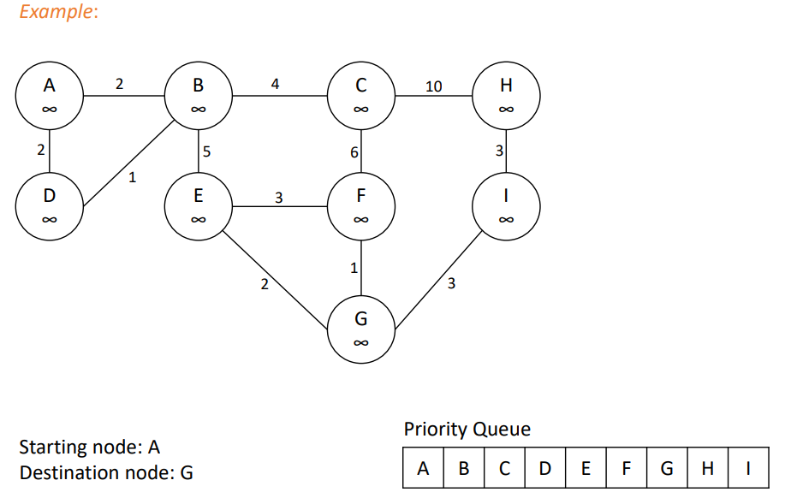

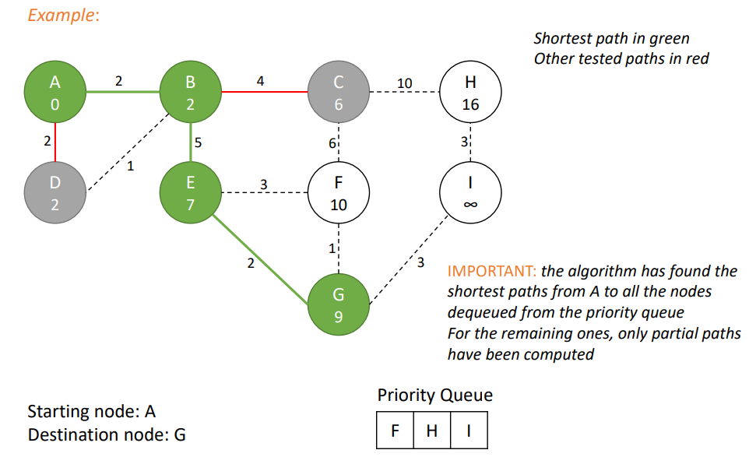

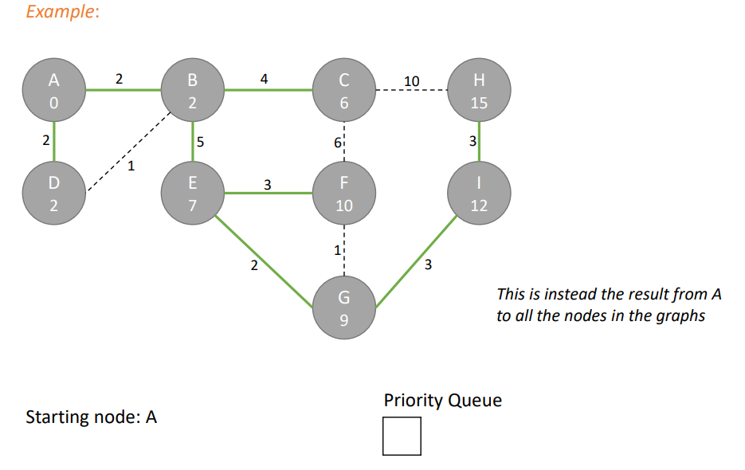

## Prim’s vs Dijkstra’s algorithm

* Both derive from Breadth First Search (BFS)
* Prim’s work with both positive and negative weights, Dijkstra only with positive one
* Dijkstra works with both directed and undirected graphs. Prim’s only undirected one
* Both are greedy but minimizes different things
  + Prim’s minimized total weight of the spanning tree
  + Dijkstra’s minimized the path from a source to a destination
* If it reaches all nodes, dijkstra also creates a spanning tree. But not guarantees that it is a minimum spanning tree

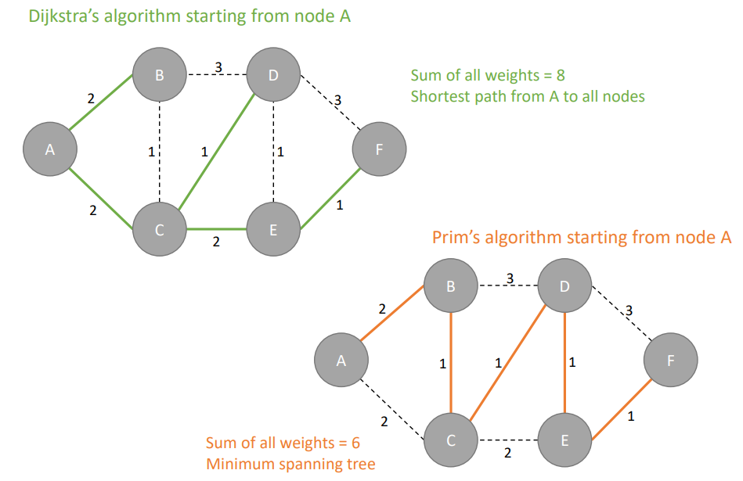

## A* Search Algorithm

[A* (A Star) Search and Heuristics Intuition in 2 minutes](https://youtu.be/71CEj4gKDnE)

Extension of Dijkstra’s algorithm that uses a heuristic to efficiently find the shortest path from a source to a destination in a graph

A* find the shortest path from a source to a destination. Does not compute the shortest path tree from a source node to all other reachable nodes in the graph (differ from Dijkstra)

A* is **optimally efficient**: there is no other optimal algorithm guaranteed to expand fewer nodes that A*

It have a “brain” since it takes smart decision at each step (not an AI algorithm)

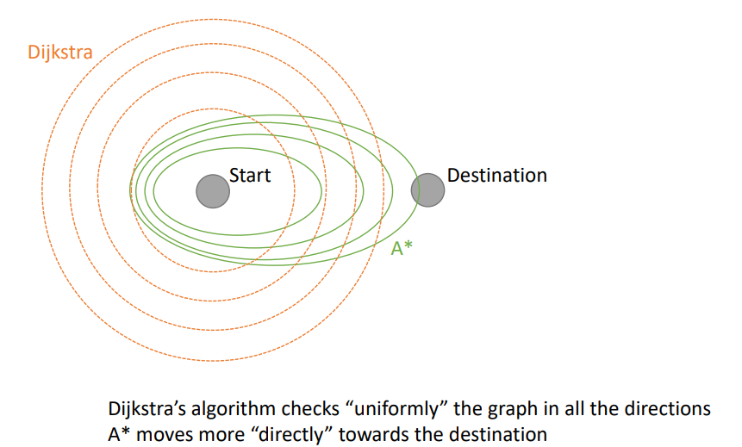

### Procedure

A* follows the same steps of Dijkstra beside the logic used to select the next node

Dijkstra at each iteration chooses the path with the lowest cost from the source node (aka node with the lowest distance value)

A* at each iteration select the path that minimizes ***f(n) = g(n) + h(n)*** where

*n* possible next node on the path

*g(n)* cost of the path from the starting node to *n*

*h(n)* heuristic function that estimates the cost from *n* to the destination node

There is no heuristic function optimally in all the cases

Exact heuristic: returns for each node its exact distance to the destination. Extremely time consuming to compute in most of the cases

Approximation of the exact heuristic are good enough to find the shortest path faster than dijkstra’s algorithm

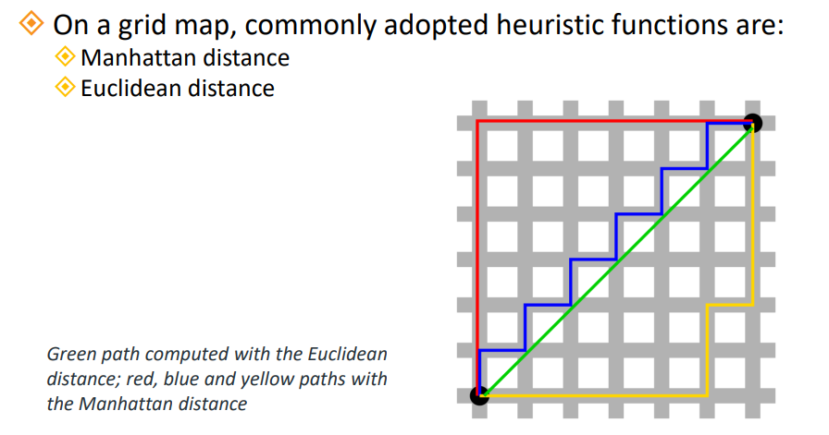

**Manhattan distance**: $h(n) = abs(n.x - goal.x) + abs(n.y - goal.y)$

**Euclidean distance**: $h(n) = \sqrt{(n.x - goal.x){}^{2} + (n.y - goal.y){}^{2}}$

A* will find the shortest path only if the heuristic function is admissible (aka provides an estimation that is less than or equal to the actual cost). If overestimated can cause to examine pathgrs that should be ignore or find suboptimal paths

# Summary

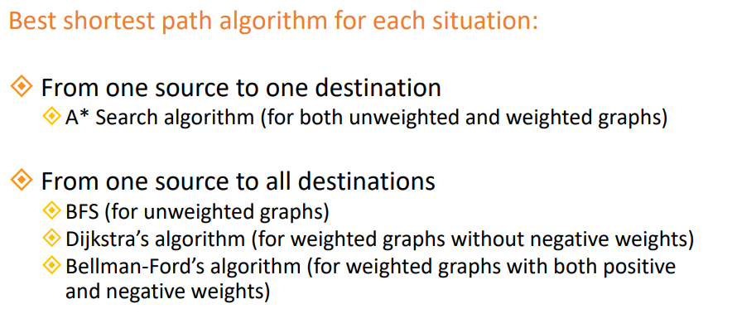

1. A priority queue is a queue in which the elements are inserted and removed in function of their priority